Guide for Java developers to get started at Uhaul

Version: 2021.02.14

To get started at Uhaul, a Java developer needs to know/do:

* Get access and Install software needed for Uhaul’s Java programming (1)
* Mainframe basic (2)
* Deploy a Java program to the Mainframe for Testing and Production (3)
* Azure DevOps – Boards and Repos (4)

Contents

Section 1: Install software needed for Uhaul’s Java programming 3

Step 0: Get a work computer with accounts for VPN, Mainframe, TFS, Windows login 3

Step 1: VPN, Network drives (and turn your personal computer to work computer) 3

VPN 3

Network drives 3

Remotely control your work computer 4

Step 2: Mainframe terminal emulator Web2Host 5

Step 3: JDK and Eclipse 5

Step 4: IBM z/OS explorer plugin for Eclipse 6

Install IBM z/OS explorer 6

Connect to the mainframe 6

Browse MVS beyond your T-number folder by filters 8

Step 5: Microsoft Team Foundation Server plugin for Eclipse 8

Step 5.1: Install Team Foundation Server (TFS) as a plugin for Eclipse 8

Step 5.2: Connect to Uhaul’s TFS server 9

Step 5.3: Import projects from Uhaul TFS server 13

Step 5.4: Correct imported projects 15

Some operations with TFS 22

Step 6: Database manager – Dbeaver or SQL Server Management Studio 23

Option 1: SQL server management studio 24

Option 2: Universal database manager: Dbeaver 26

Where to get database accounts and connection strings? 33

Step 7 (Optional): Tools to compare, sort files 33

Section 2: Mainframe basic (…) 35

Section 3: Deploy a Java program to mainframe 36

Run a Java program on the mainframe (for personal testing) 36

Step 1: upload the Java program to the mainframe’s Unix filesystem 36

Step 2: create a shell script that prepare environment variables for JVM to launch the Java program 38

Step 3: write a JCL to call the Java program with the prepared JVM configuration 40

Step 4: run the JCL 43

Process to replace Ideal by Java programs on mainframe’s production 43

Step 1: get tester’s approval 43

Step 2: get user’s approval 43

Step 3: rewrite JCL (log it out, rewrite, get approval, log it in) 44

Step 4: submit Java source code to TFS’s production repos 48

Step 5: submit traveler form to the manager 49

Step 6: document what your program does in APCDOC 49

Section 4: Azure DevOps - Boards and Repos 52

What is Azure DevOps? 52

Overview of services in Azure DevOps 52

First glance at Uhaul’s Azure DevOps for Java developers 53

Azure BOARDS with U-Haul IT project 53

Information of a work item 54

List work items: assigned to you, mentioning you, recently updated, etc 56

Change the states for your assigned work item 57

Assign a work item to someone 57

Query work items 59

Azure REPOS with Operations project 61

See who commits what code 62

Compare/Go back to an old version of your code 62

# Section 1: Install software needed for Uhaul’s Java programming

## Step 0: Get a work computer with accounts for VPN, Mainframe, TFS, Windows login

After having Uhual’s smid number, you should ask Uhaul Tech Support (see the phone number in the following) for a **work** computer with accounts/access for:

* Windows login for work computer (this will be used for network drives)
* VPN
* Mainframe
* Azure DevOps and TFS access for a *programmer.* (Quick check if you have TFS account yet: <https://dev.azure.com/uhaul/_usersSettings/tokens>)
* Uhaul HR account for uhaullife.net, uhaul.net, uhaulsupport.com

**With a VPN account and a Windows login for work computer, you can use your personal computer as if it’s a work computer.**

|  |
| --- |
| Uhaul tech support contact  Call-ins: 602-325-1679 – ext 525700  Network Operations (Field): 602-760-4923 (606903, Opt 6)  Support portal (for issuing a ticket): [www.uhaulsupport.com](http://www.uhaulsupport.com)  Helpdesk and IT infrastructure: TEAMS or [midtown_support@uhaul.com](mailto:midtown_support@uhaul.com) |

## Step 1: VPN, Network drives (and turn your personal computer to work computer)

If you use work computer at Uhaul’s office (i.e. connect to Uhaul’s network) then network drives will be shown automatically. If you want to use your personal computer connecting to your home Internet connection as if it’s a work computer: install VPN and set up network drives.

### VPN

You should ask the Tech center for a VPN certificate for Programmer’s access (which is greater than a non-programmer access) and follow their instructional email to install the certificate and Cisco AnyConnect (vpn software).

You need to log in VPN before installing following software (except JDK, Eclipse).

### Network drives

To get Uhaul network drives at your personal computer, at Windows command prompt or power shell, run the following commands to map network drives to G: I: M: U: drives on your personal computer:

|  |
| --- |
| **net use G: \\nacl01fs01.uhaul.amerco.org\DEPARTMENTS\vpo\group**  **net use I: \\adfs01.uhi.amerco\interdepartment\Mainframe**  **net use M: "\\adfs01.uhi.amerco\interdepartment\vp Operations"**  **net use U:** **\\adfs01\users\1299645** |

For each command you will enter your username of the form **uhi\xxxxxxx** (where xxxxxxx is your Smid number) and password, which is the password of Windows login for your work computer.

If everything goes well, you should have:



Use “net use” at Windows command prompt or power shell to check the status:

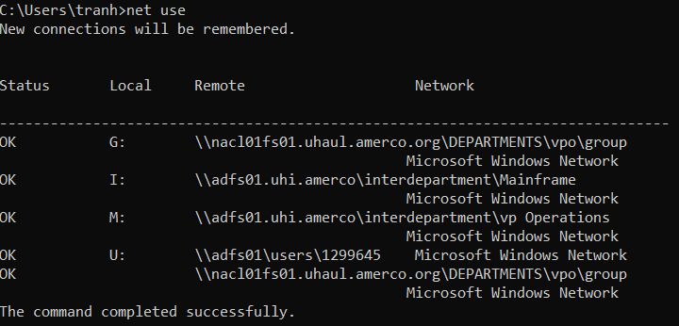

### Remotely control your work computer

If you don’t want to set up your personal computer as a work computer as above, you can still use your personal computer to remotely control your work computer by:

* Set the controlled computer to allow remote connection:
  + select **Start** > **Settings** > **System** > **Remote Desktop**, and turn on **Enable Remote Desktop**. The Windows on this PC must be the PRO version.
  + Make note of the name of this PC under **How to connect to this PC** or its ip address. You'll need this later. (To get the ip address: at Windows command prompt, run “ipconfig” and copy the number of line: IPv4 Address)

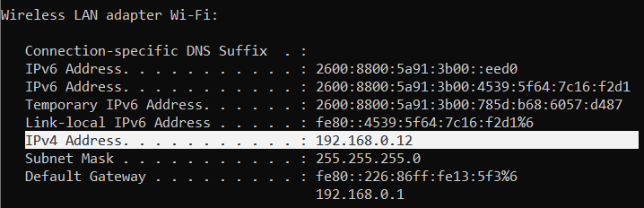

* Use the controlling computer to remotely connect the controlled computer:In the search box on the taskbar on your local Windows 10, type **Remote Desktop Connection**, and then select **Remote Desktop Connection**. In Remote Desktop Connection, type the name of the PC or the IP address above and your username of the format **uhi\xxxxxxxx** (xxxxxxx is a smid number), you want to connect to, and then select **Connect**.

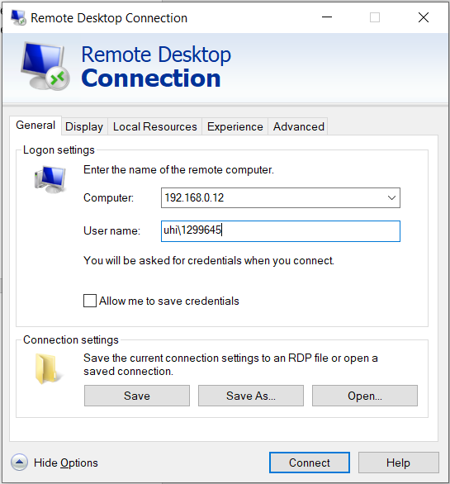

## Step 2: Mainframe terminal emulator Web2Host

You connect to the mainframe through a mainframe terminal, or more precisely, a mainframe terminal *emulator*. Uhaul’s mainframe terminal is Web2Host, which bases strictly on Internet Explorer.

Install this mainframe terminal by:

**Either** “Run as Administrator” on install_pgms_Menu.bat and choose Mainframe and then copy the shortcut “mainframe.lnk” to your Windows desktop/taskbar.

**Or** download *WEB2HOST_2009-619.msi* installer from

I:\Web2Host network drive or \\adfs01.uhi.amerco\interdepartment\Mainframe\Web2Host

and then run it.

The both ways create a shortcut to the following link

"C:\Program Files\Internet Explorer\iexplore.exe" <http://web2host.uhi.amerco/Pec/Ecomes.zwh?sessionprofile=3270dsp/Sessions/mainframe+Nologo=1>

So when you open the mainframe terminal, you actually open the web2host.uhi.amerco webpage by Internet Explorer.

Web2Host uses activeX of Internet Explorer, so you cannot replace Internet Explorer by Edge/Chrome/Firexfox/Opera.

## Step 3: JDK and Eclipse

The newest version for JDK and Eclipse that can work with the mainframe is **JDK 8** and **Eclipse 2020-06**.

(Java developers need “IBM z/OS explorer” plug-in for accessing mainframe’s file from Eclipse, and the IBM z/OS explorer plugin version 3.2 cannot run with JDK after 8. Also, Eclipse after 2020-06 doesn’t work with JDK 8 any more. So the IBM z/OS explorer 3.2 forces JDK to be 8 and Eclipse to be 2020-06.)

Beside installers, both JDK and Eclipse provide non-install packages so that you can unzip and just run without installing.

JDK 8: <https://adoptopenjdk.net/releases.html?variant=openjdk8&jvmVariant=hotspot>

Eclipse 2020-06, choose SE or EE: <https://www.eclipse.org/downloads/packages/release/2020-06/r>

To remove Eclipse, besides delete its Eclipse folder, you need to delete **.p2, .eclipse, .tooling** folders in users\usrname folder.

## Step 4: IBM z/OS explorer plugin for Eclipse

With the mainframe terminal web2host, it’s difficult to upload/download files between your local computer and the mainframe. The IBM Aqua 3.2 package helps you not only to do this but also many things with the mainframe. However, we need only one small feature of this huge package: IBM z/OS explorer.

### Install IBM z/OS explorer

In Eclipse, choose from the menu bar: Help\Install New Software

Click on Add… and then add the following link:

[**https://public.dhe.ibm.com/ibmdl/export/pub/software/htp/zos/tools/aqua3.2/**](https://public.dhe.ibm.com/ibmdl/export/pub/software/htp/zos/tools/aqua3.2/)

Give this link a name, like “IBM z/OS explorer” and then “Add”

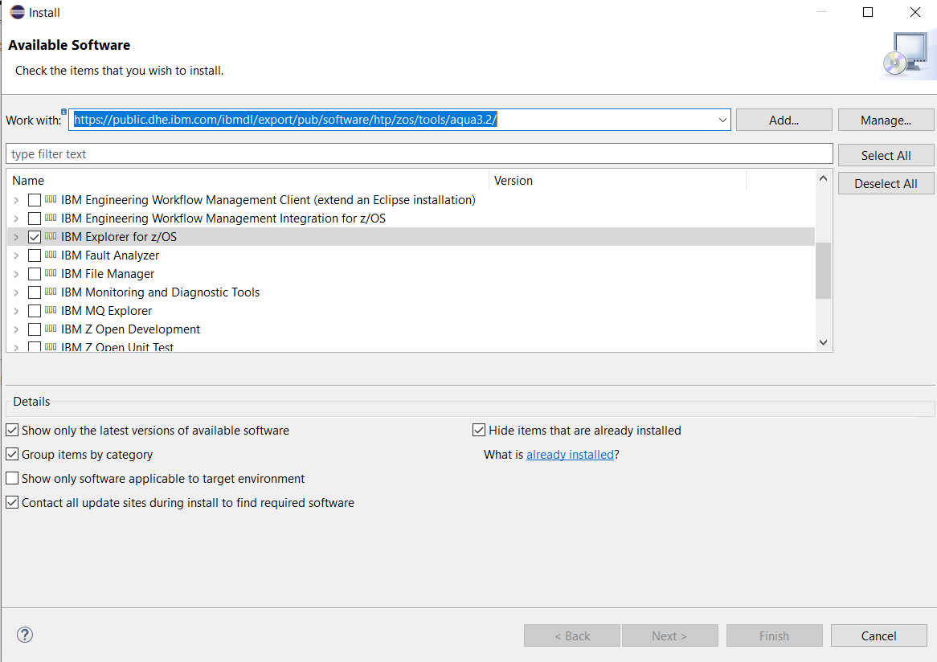Check “IBM explorer for z/OS” and then install it. If asked, choose “install any way” and then restart Eclipse.

### Connect to the mainframe

After successfully installing the **IBM Explorer for z/OS**, you can now connect to the Mainframe through the Remote System tab.

To view the Remote System tab, in Eclipse menu, choose Windows > Show Views > Other … > Remote Systems > Remote System, and then Open. You should see the Remote System tab and you can drag this tab to your favorite place.

Under “Remote Systems”, expand “New Connection”, double-click “z/OS …”

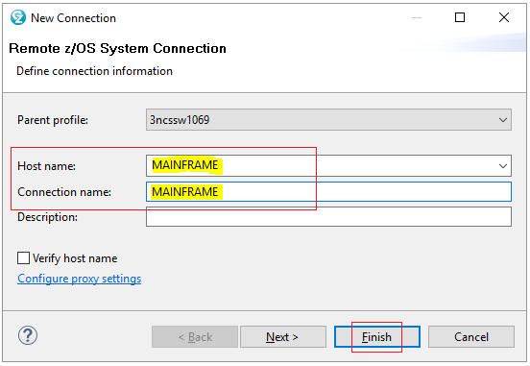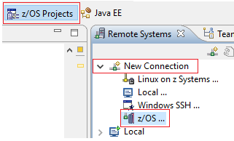

Set “Host name” and “Connection name” to “MAINFRAME” > Next > Finish

Right-click “MAINFRAME” > Connect and enter the username and password from your mainframe account. (Note the username starts with T and then your Smid number without the first digit.)

In the first time logging in the mainframe, you will be asked to change your password.

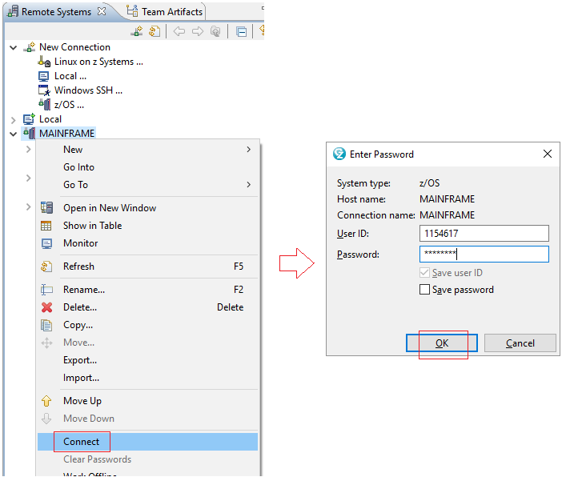

If you follow through all step above, you should see under Mainframe node:

* UNIX Files: the whole filesystem of Unix, notice Root?
* MVS Files: the MVS filesystem. By default you see only your personal T-number folder (PDS). You can browse other folders by creating filters.
* JES: your jobs (processes) on the mainframe

Also create a Local connection to your local computer so that you can upload/download files between your computer and Unix and MVS on the mainframe.

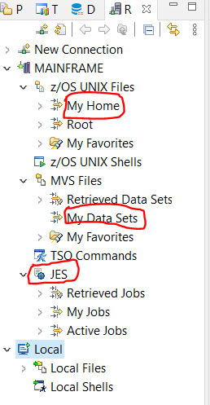

### Browse MVS beyond your T-number folder by filters

The word “filter” means restricting; however, using filters in the MVS filesystem helps you to explorer other folders beyond the T-number folder, which is created by default.

An example of using filter: you want to copy a data set from T12345 folder of a colleague to your person Txxxxx folder. Your colleague’s T12345 folder does not show up, so you create a filter for it, namely T12345.* and then you can browse all the dataset in T12345. Copying is done by drag-n-drop or CTRL-C, CTRL-V.

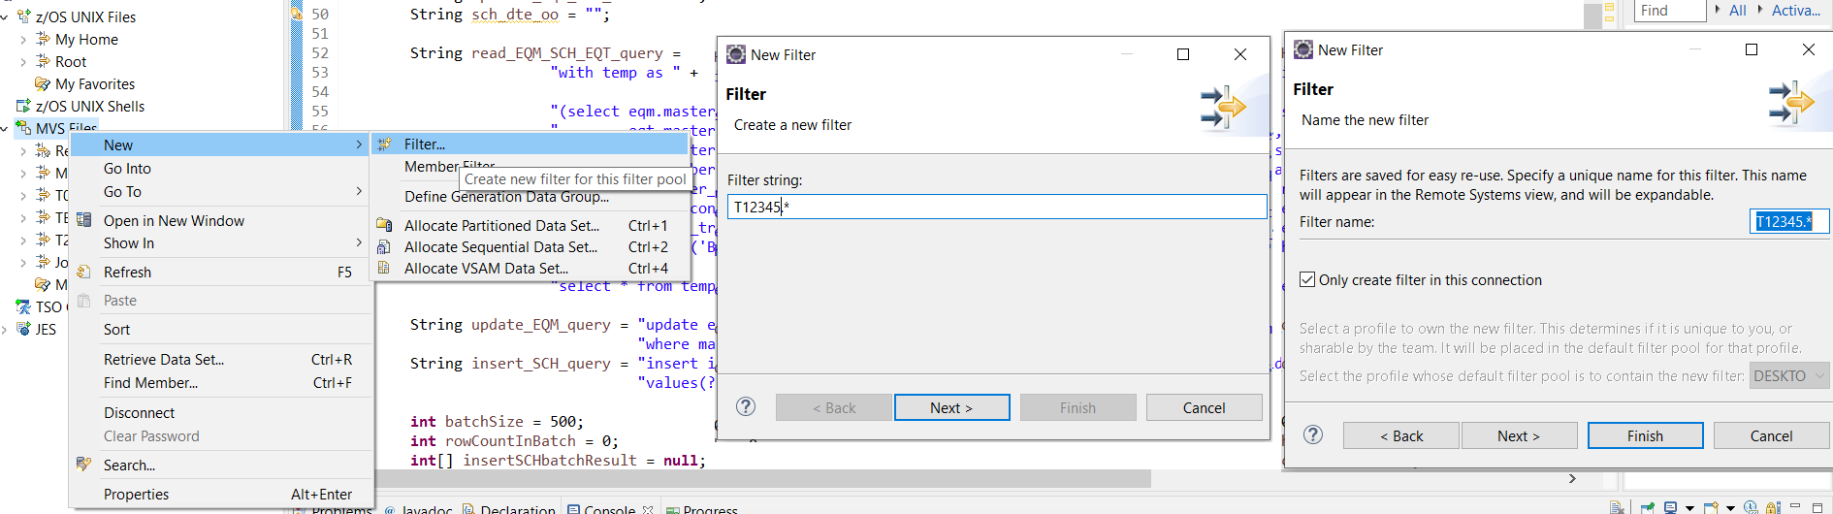

## Step 5: Microsoft Team Foundation Server plugin for Eclipse

Microsoft Team Foundation Server (TFS) is a version control system (VCS), like Git. (The difference is that TFS is a centralized VCS while Git is a distributed VCS)

### Step 5.1: Install Team Foundation Server (TFS) as a plugin for Eclipse

Go to <https://github.com/Microsoft/team-explorer-everywhere/releases>

Download [TFSEclipsePlugin-UpdateSiteArchive-14.135.0.zip](https://github.com/microsoft/team-explorer-everywhere/releases/download/14.135.0/TFSEclipsePlugin-UpdateSiteArchive-14.135.0.zip)

(For JDK compatibility reason, the TFS plugin on Eclipse marketplace doesn’t work with new Eclipse 2020-06, so we have to download manually TFS plugin on Microsoft github page)

In Eclipse menu, choose Help > Install New Software … > Add … > Local … > Select the folder to the TFS zip file above > Enter a Name > Add

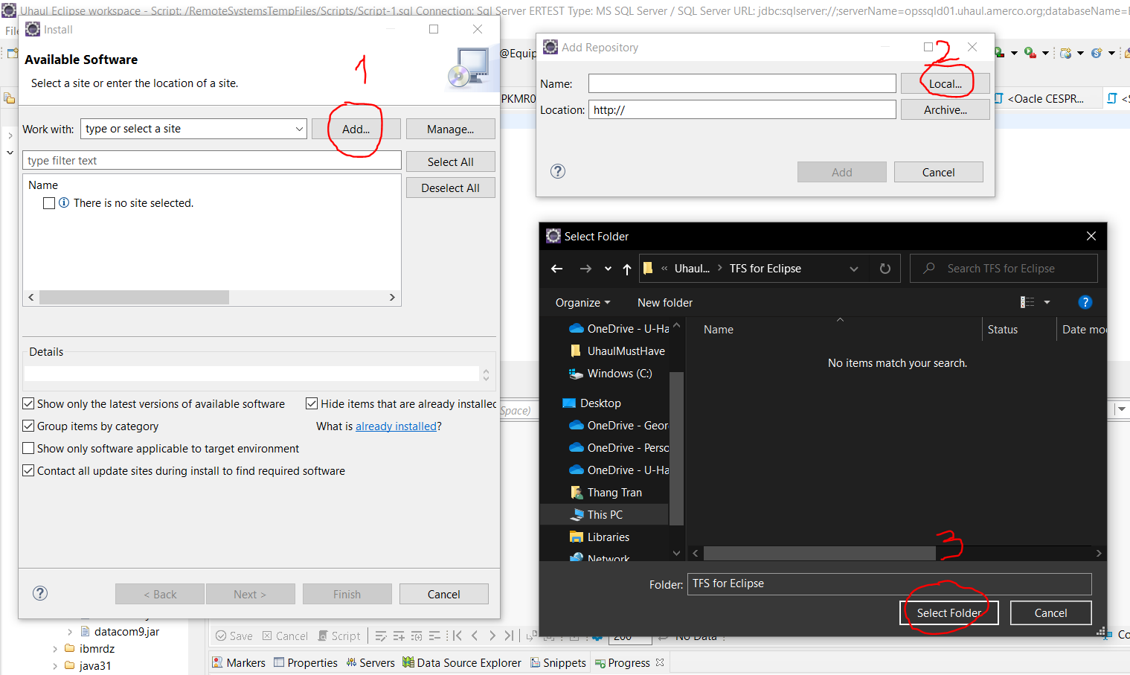

And then you should have:

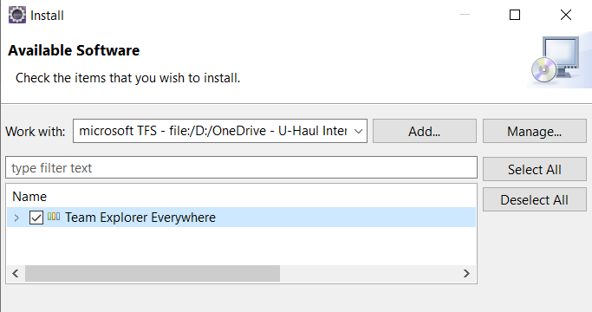

Check “Team Explorer Everywhere” and Click on Next, install anyway and restart Eclipse.

### Step 5.2: Connect to Uhaul’s TFS server

To view TFS, in Eclipse menu, choose Window > “Show View” > “Team Explorer” and you can drag the Team Explorer tab to your favorite place.

In Team Explorer tab, click on “Connect to Team Services or a Team Foundation Server”, “I have read and accept terms”, “Next”.

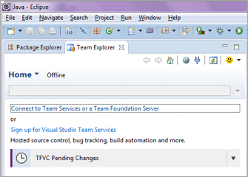 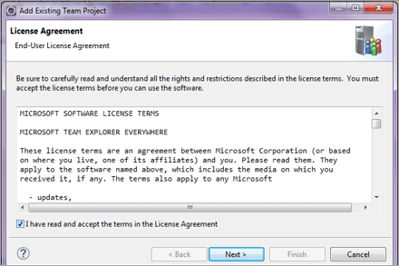

The next step has 2 options, try “Browse Visual Studio Team Services” first, if it doesn’t work, try “Connect to a Team Foundation Server or Team Services Account”

#### Option 1: Browse Visual Studio Team Services

Select the option “Browse Visual Studio Team Services” > Next>

If you don’t get the following dialog box, move to the next option “Connect to a Team Foundation Server or Team Service Account”

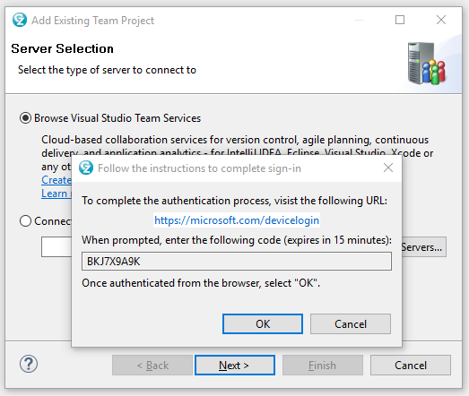

Copy the Code that is now prompted and click on the link to <https://microsoft.com/devicelogin>

Enter the code and proceed through the prompts of logging in to link the device.

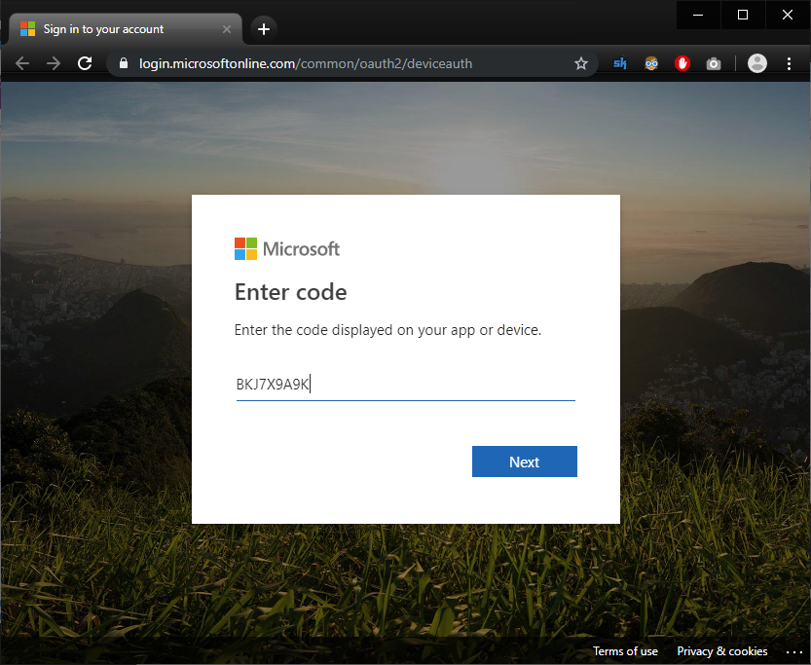

FYI: There has been an occurrence of being required to login and enter code again

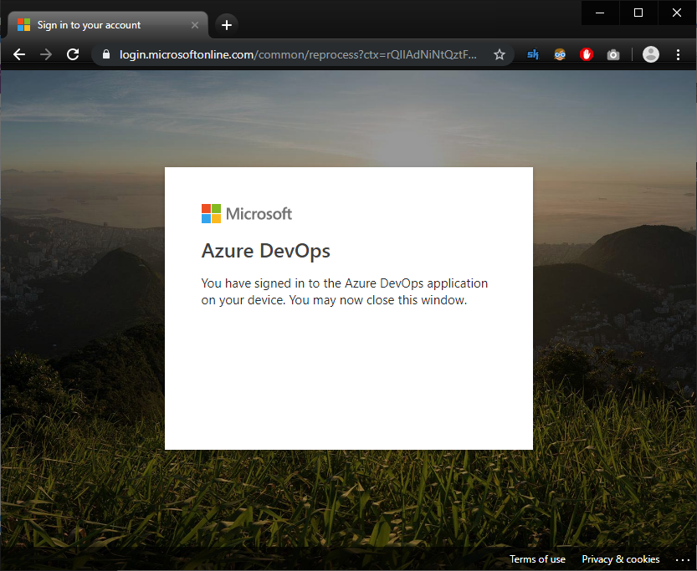

Note:

If you are prompted about a “Master Key”, click “No”

#### Option 2: Connect to a Team Foundation Server or Team Services Account

When option “Browse Visual Studio Team Services” doesn’t work, you choose option “Connect to a Team Foundation Server or Team Services account” and enter <https://uhaul.visualstudio.com/>

Choose “Servers …” > “uhaul.visualstudio.com” > “Enter Credentials …” > “Personal access token (all scope)”

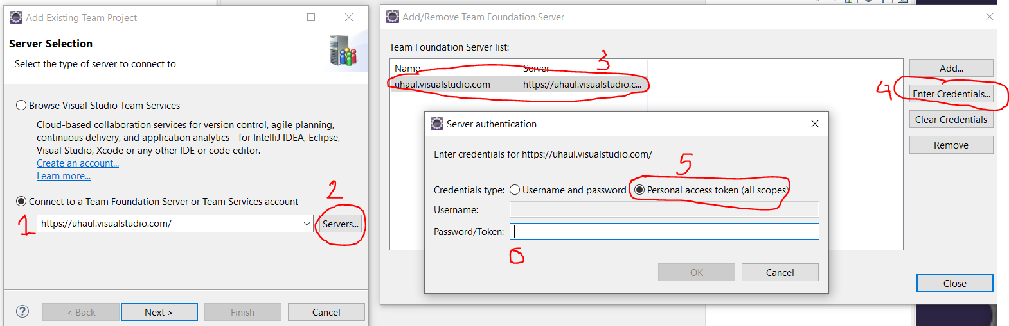

Enter the access token, “OK” > “Close” > “Next”

Where to find the access token?

Go to <https://dev.azure.com/uhaul/_usersSettings/tokens>

If there are already some tokens, choose “Regenerate” and then “Regenerate” again.

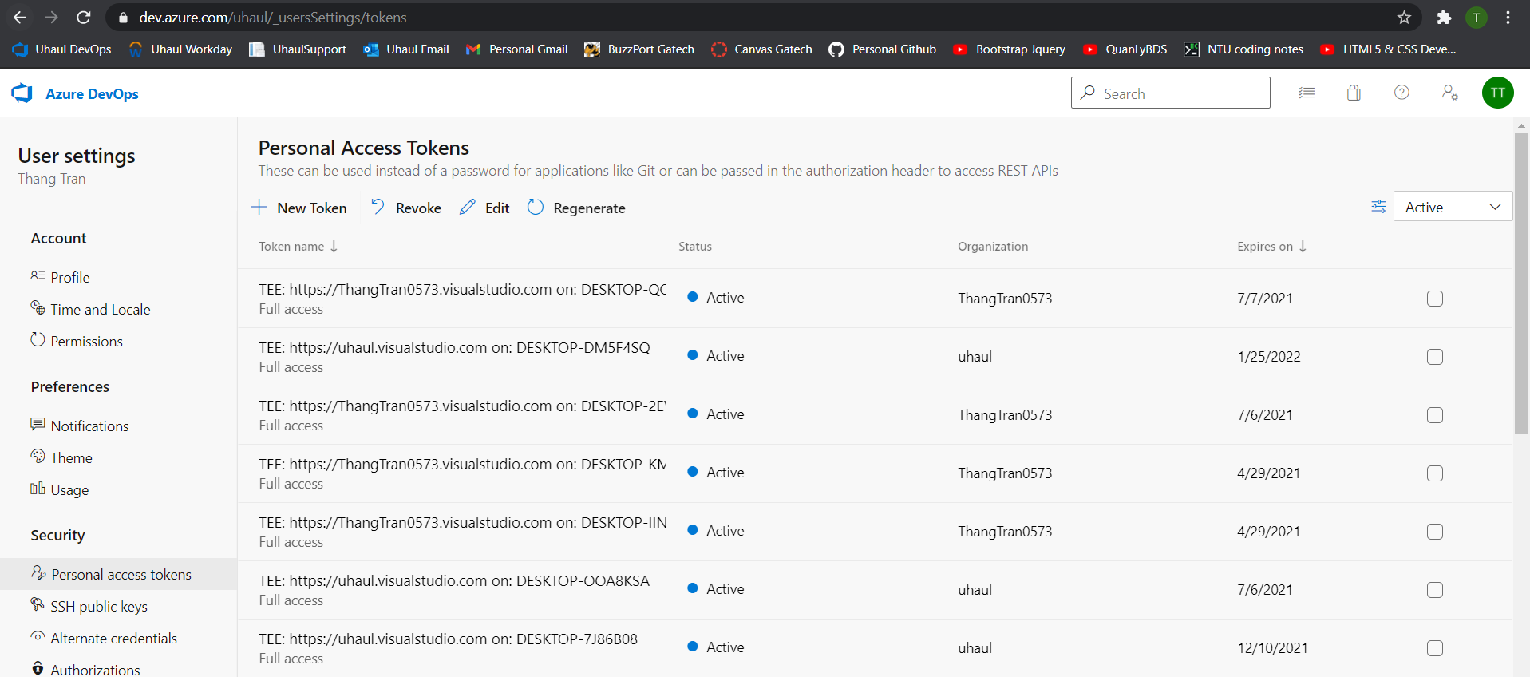

If you don’t find any existing token, choose “New Token” and then fill in the form

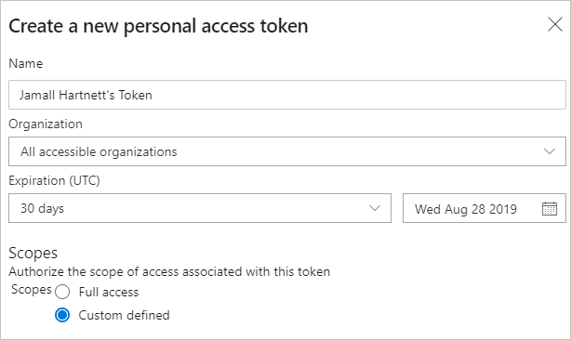

Finally, click on copy icon and you have a token in clipboard.

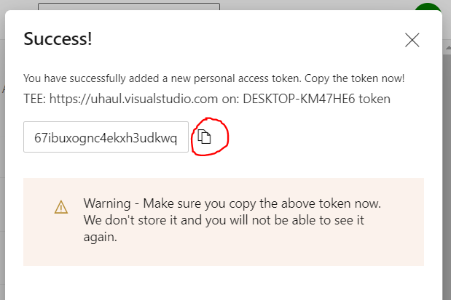

### Step 5.3: Import projects from Uhaul TFS server

After connect to Uhaul TFS, you will have:

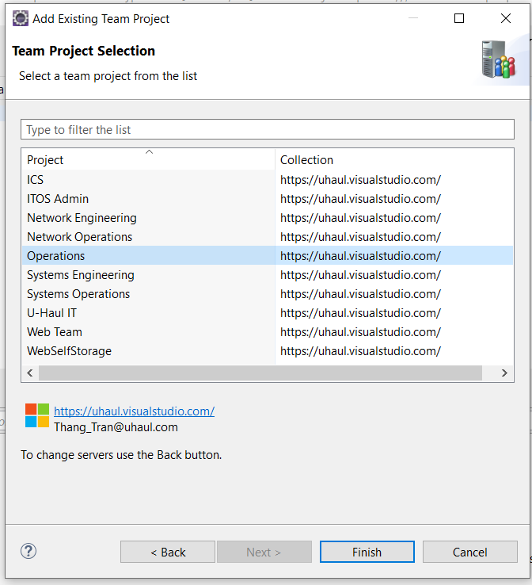

Select “Operations” > Finish

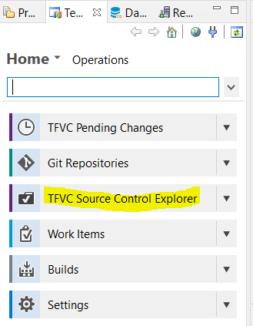In the Team Explorer tab, click on “TFVC Source Control Explorer”

Expand Operations then right-click “datacom_development” > Import…

Select the following (hold down “CTRL” then click each one to select multiple folders):

• cesp01

• cesp01_development

• datacom

• datacom_development

• datasources

• datasources_development

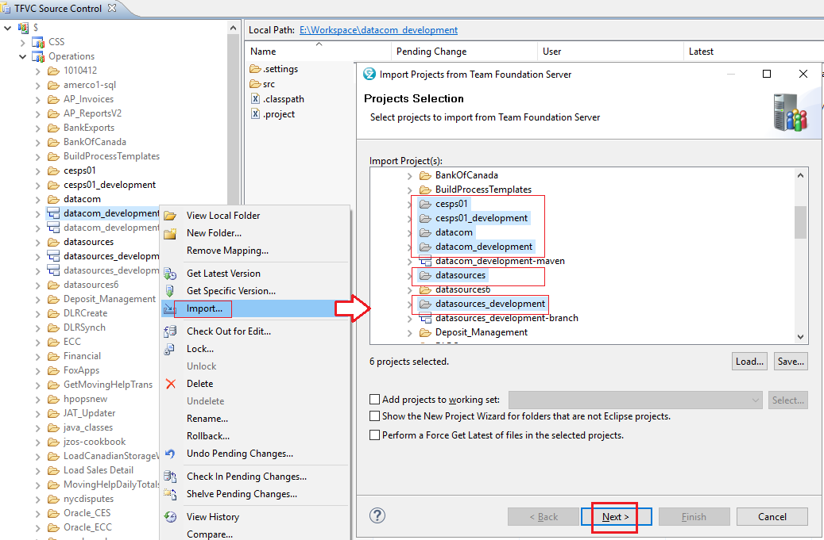

Click Next > Finish

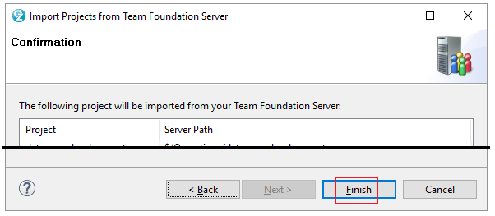

You should now see the 6 folders in your “Project Explorer”

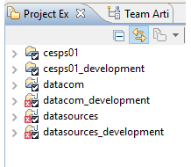

### Step 5.4: Correct imported projects

The projects that you just imported from Uhaul’s TFS cannot compile immediately because the build path for those projects are set up for Uhaul server, not your local computer. So you need to fix this.

#### Correct the project nature

Sometimes, the imported projects are not recognized as Java projects (the project icons in Project Explorer/Package Explorer don’t have “J”), so you need to set them as Java projects.

In the “Project Explorer”, right click on the project that don’t have “J” icon and then Properties > Project Nature > Add .. > Java > OK

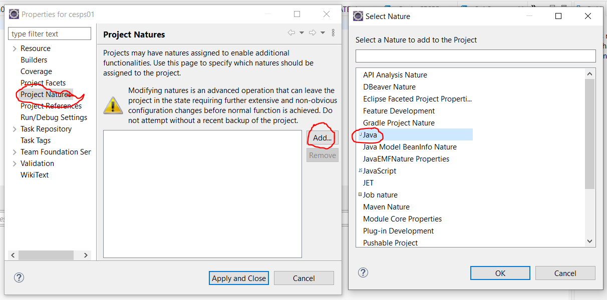

#### Correct build path

The Java projects are set up on the server with the build path on the server, so when you download the projects to your local computer, the build path on the server will likely not match your local computer. This leads to “missing jar files” in the build path like below:

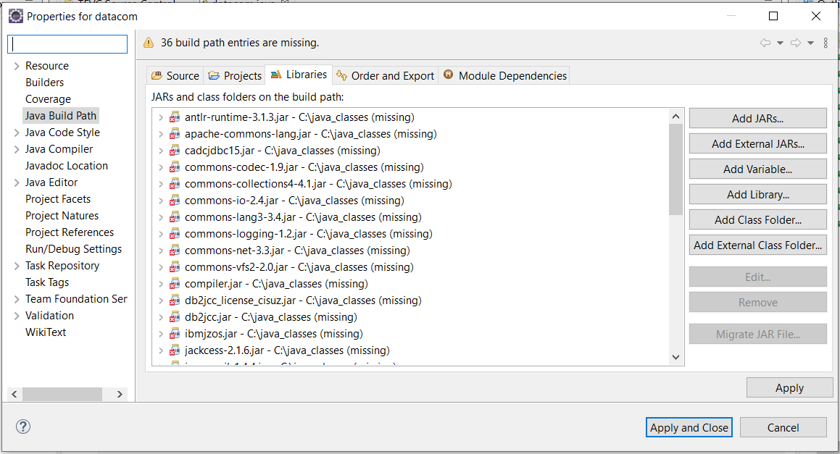

You need to add the jar files manually by

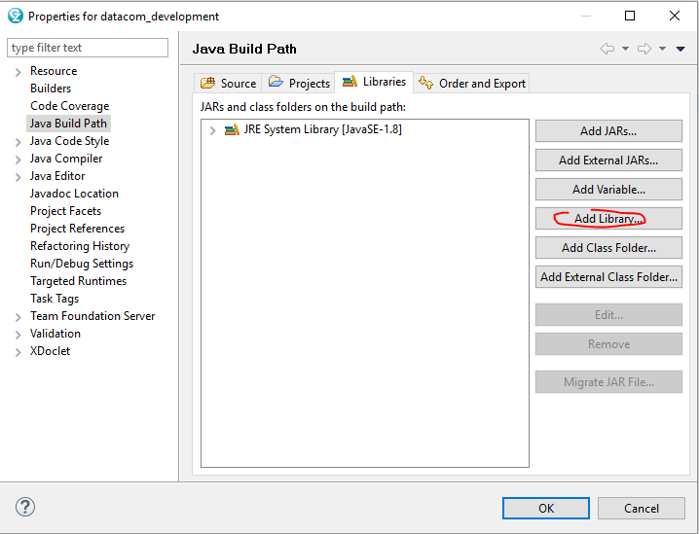

Select “User Library” > Next

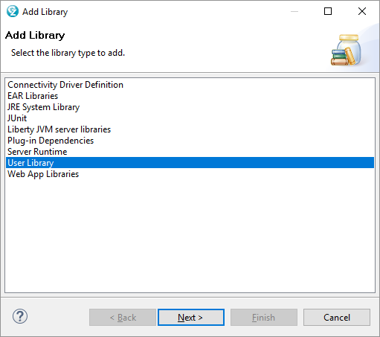

Click “User Libraries…”

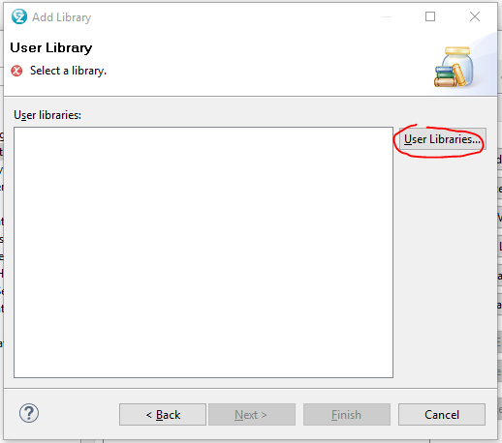

Click “New…” then enter what you want. I entered my Last Name then hit “OK”

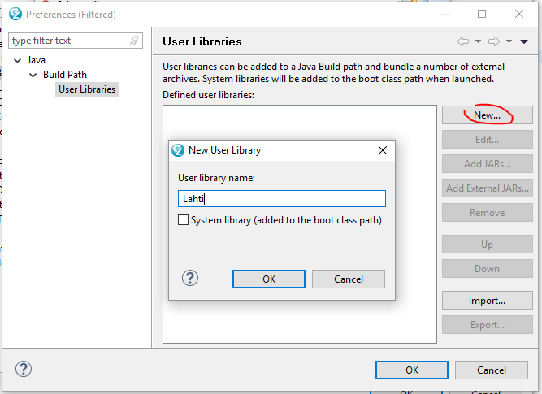

Click “Add external jars…”, select all (ctrl + a) jars in the “**java_classes**” folder* then hit “OK”

*Found in I:\Software\dependencies\Operations\

OR (full path)

\\adfs01.uhi.amerco\interdepartment\Software\dependencies\Operations\

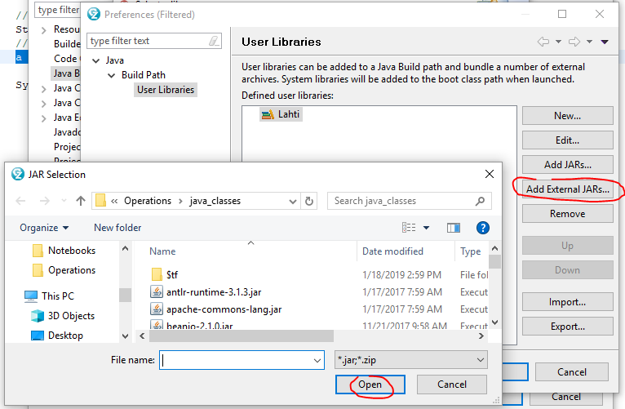

Click “OK”

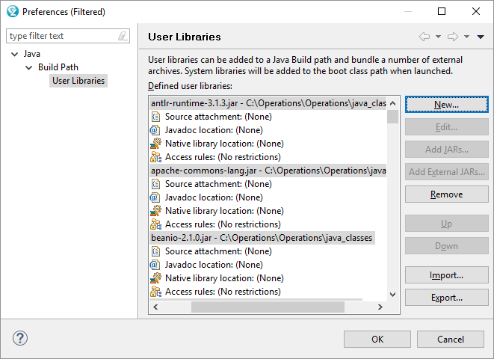

Click “Finish”

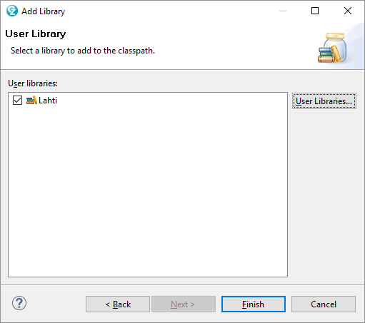

Click “OK”

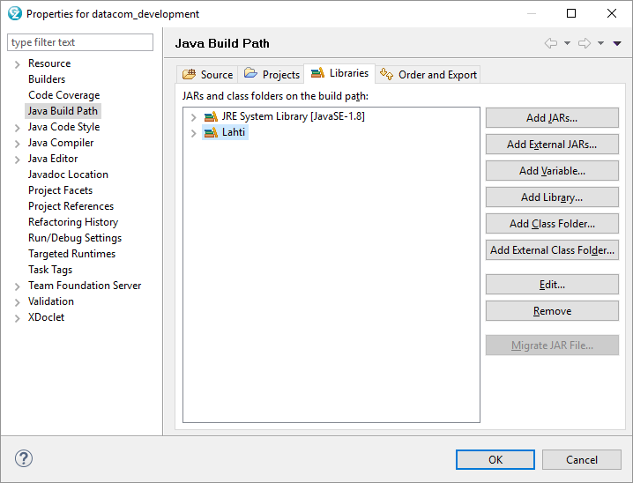

#### Step 5.4: Correct project dependencies

Some project depends on other projects, e.g. datacom_developement depends on datasources_developement, importing projects from TFS sometimes breaks this dependency, so you need to correct.

**Automatically:**

Click on the “import cannot be resolved” notification

Double-click on the “Fix project setup…”

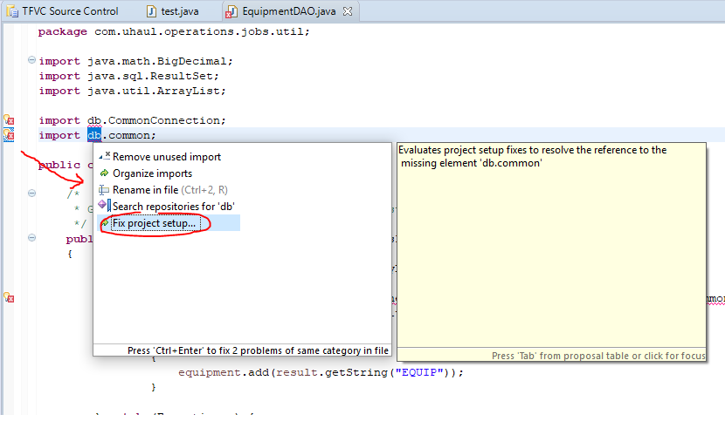

Since “datacom_development” makes calls to “datasource_development”, it should populate “add project ‘datasources_development’ to build path of ‘datacom_development’”

Hit “OK”

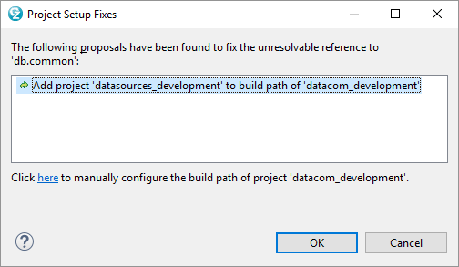

Note: If that does not work, be sure the project that contains the sources is imported.

**Manually:**

You can also perform the Build Path by right-clicking the project > build path > configure build path

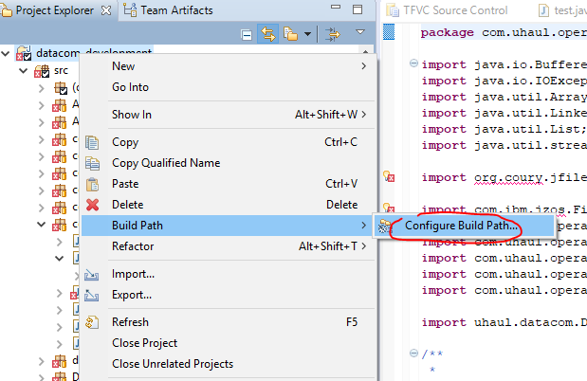

From here, click on “Java Build Path” (if not already) > navigate to the “Projects” tab then click Add

Place a check besides the project needing to be added, then OK

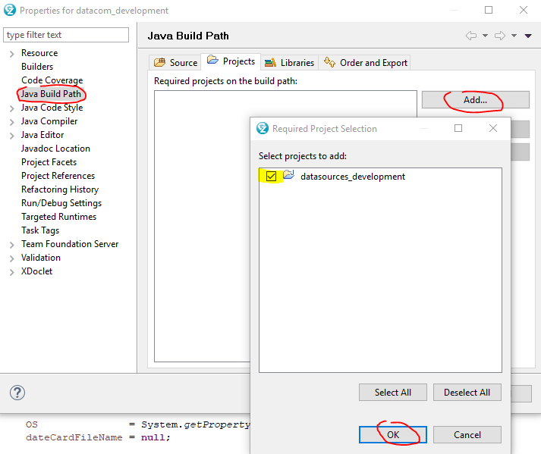

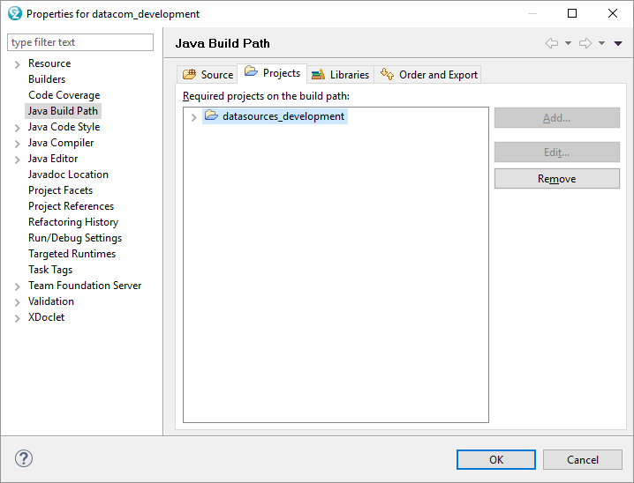

### Some operations with TFS

#### Get the latest version

Projects on TFS will change over time, to be sure you have the latest versions of packages in TFS, simply right-click the Project (in Project Explorer) > Teams > Get Latest Version. It is recommended to do this at least once a week.

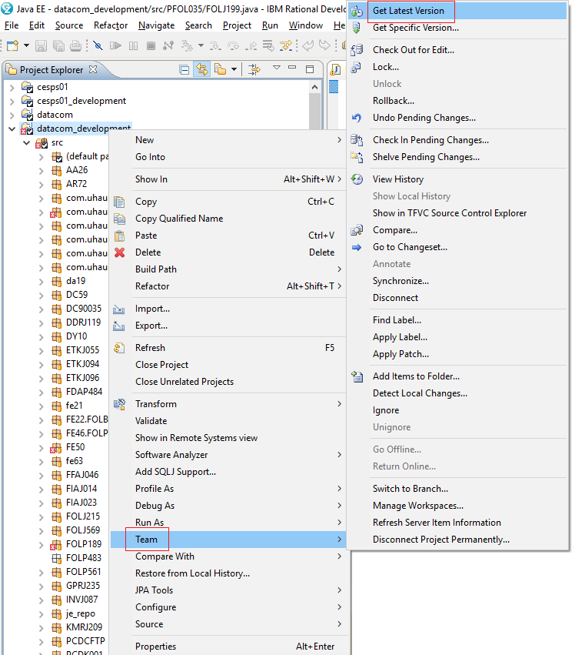

#### Commit Changes

Navigate to “Team Explorer” and be sure everything (settings etc) are excluded and click “Check In”

Another way to do it..

Right-click the changed file then “Check in pending changes”

#### Relating Work Items to Source File

Under Team Explorer, Click on the “TFVC Pending Changes”,

Under “Related Work Items, type in the ID of the Task and click Add

## Step 6: Database manager – Dbeaver or SQL Server Management Studio

To run SQL queries and other database management, you can install SQL Server Management Studio (stand alone software) or Dbeaver (as an Eclipse plugin or as a standalone software).

SQL Server Management Studio obviously is designed for managing only SQL server, but you can query other databases like Oracle, Datacom by embedding the query into function openquery(); however, the queries are limited. (Openquery() works because Oracle, Datacom servers are linked to SQL server).

In contrast, Dbeaver is a universal database manager, so you can query/manage directly any database servers (Oracle, MS SQL server, Datacom) in a same manner.

### Option 1: SQL server management studio

SQL server Management Studio (SSMS) is a tool to manage *existing* SQL server databases; if you want to run a database server on your local computer, i.e. you want to run a service, you need to install SQL server Express/SQL server Developer (free).

#### Install SSMS and connect to Uhaul SQL servers

Download SSMS at

<https://docs.microsoft.com/en-us/sql/ssms/download-sql-server-management-studio-ssms>

and follow the instructions to install SSMS (using defaults).

Run SSMS and choose SQL Server Authentication

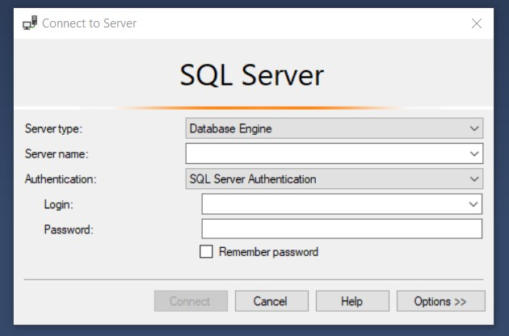

You will use 2 Sql server:

|  |
| --- |
| **Uhaul sql server for Testing**  **Server name: opssqld01.uhaul.amerco.org**  **Login: vpoperations**  **Password: W7cv89q25x** |
| **Uhaul sql server for Production**  **Server name: opssql02.uhaul.amerco.org**  **Login: vpoperations**  **Password: W7cv89q25x** |

You can add connection by choose Connect > Database Engine …

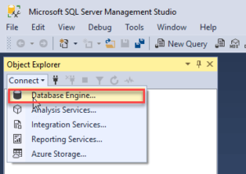

#### Running a query

To create a query, from the menu, choose File > New > Query with Current Connection

OR Expand “Databases” and right-click the desired table > New Query

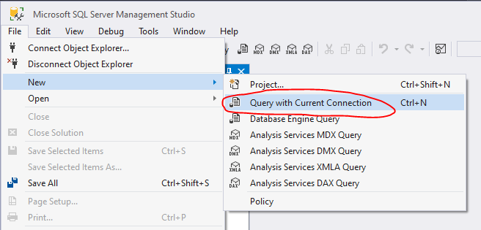 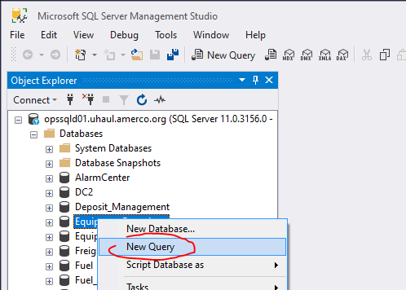

For a connection to a server, there are several databases, pay attention to the database you are working on

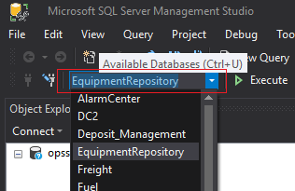

#### Query linked servers (Oracle, Datacom) through “exec at”, “openquery”

From SSMS, you can still query linked database servers (like Oracle, Datacom) by wrapping around your query with “exec at” or “openquery”. “Exec at” is newer and more powerful than “openquery”; “Exec at” can call stored procedures, insert/update tables on the linked server while “openquery” cannot but “exec at” requires RPC enabled on the linked server.

**Openquery:**

**openquery(linked_server, ‘query’)**

Example:

**select** * **from** **openquery**(datacom_prod,'select count(*) from equip_master')

**select** * **from** **openquery**("opssql02.uhaul.amerco.org",'select * from code')

**Exec at:**

**exec('query') at <linked_server>**

Example 1:

**exec**('select count(*) from equip_master') **at** datacom_test

**exec**('select * from code') **at** datacom_test

Example 2: DDL statements (openquery cannot do)

**exec**('create table tabletest(id int)') **at** datacom_test

**exec**('drop table tabletest') **at** datacom_test

Example 3: dynamic sql commands (openquery cannot do)

**declare** @cde **as** **varchar**(2)

**declare** @cde_typ **as** **varchar**(1)

**set** @cde = 'bp'

**set** @cde_typ = 'a'

**exec**('select * from code where cde = ? and cde_typ = ?;', @cde, @cde_typ)

**at** datacom_test **exec('select * from equip_master') at datacom_test**

Note: <linked_server> in both openquery and exec at above should be **datacom_test, datacom_prod, datacom_qa** or an address like OPSSQL02.UHAUL.AMERCO.ORG

### Option 2: Universal database manager: Dbeaver

Dbeaver is a ***universal*** database manager that use JDBC. It has the function to automatically download JDBC driver you need for any popular database system out there like SQL server, Oracle, Postgre or take a driver you provide for legacy database system like Datacom.

#### Install Dbeaver

Dbeaver can be installed as a standalone software at <https://dbeaver.io/download/>

or as an Eclipse plugin by:

* Either go to <https://marketplace.eclipse.org/content/dbeaver> and drag the Install icon to Eclipse
* Or in Eclipse menu, open Help > Install New Software. Paste “https://dbeaver.com/update/ee/latest/” into “Work with”, press Enter.

Click next, Install anyway and restart Dbeaver.

#### Connect to Sql server, Oracle, Datacom

##### Sql server

From Eclipse menu, choose Database > New Database Connection > SQL Server > Next

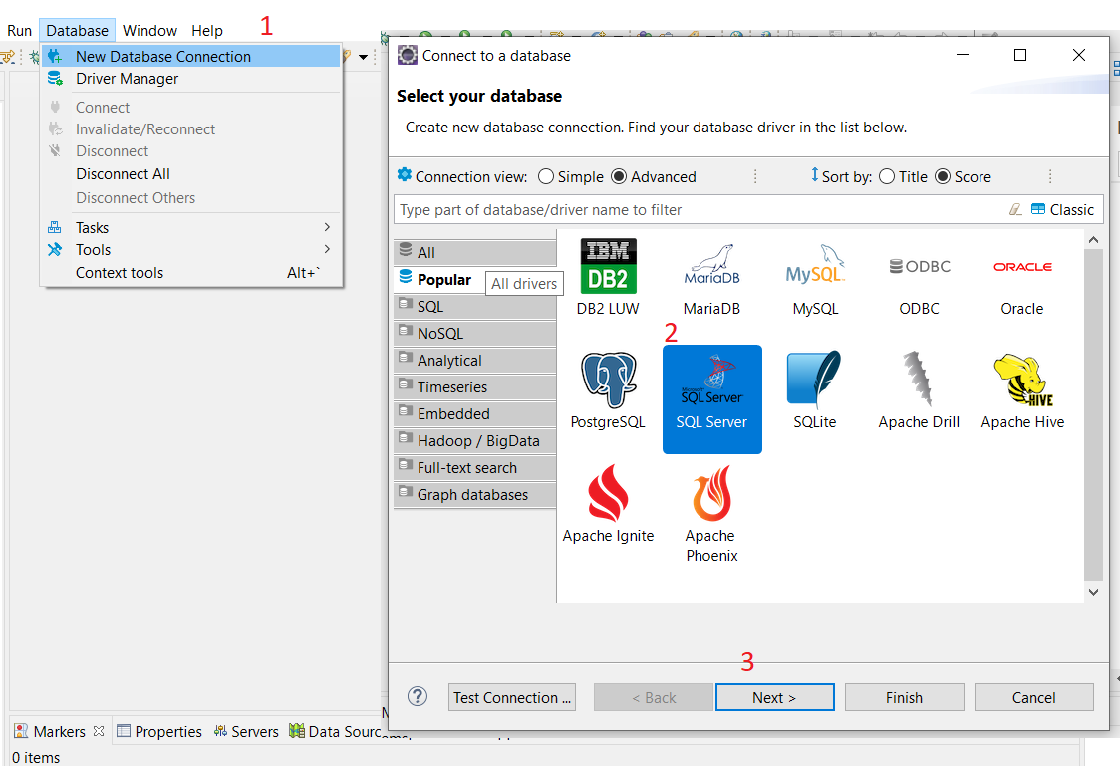

And then you enter connection info for Sql PROD as below (connection to other databases on Sql server will be presented later)

|  |
| --- |
| Connection name (whatever you name): **Sql Server PROD** (this can be any name you want)  Host: **opssql02.uhaul.amerco.org**  Port: **1433**  Database/Schema: **EquipmentRepository**  User name: **vpoperations**  Password: **W7cv89q25x** |

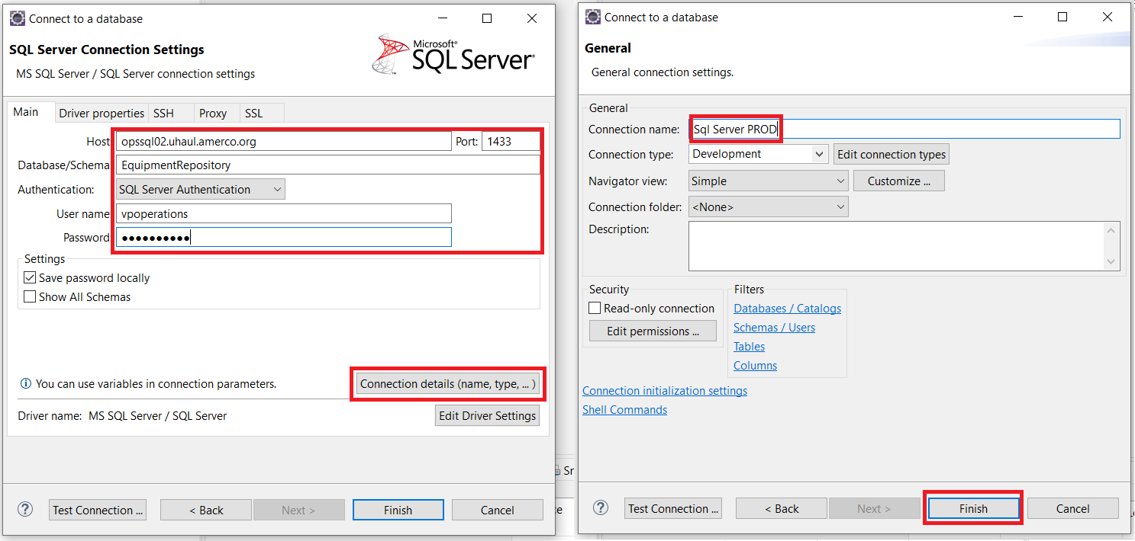

Dbeaver will ask you before it download automatically the driver it needs for Sql server. Click “Download”

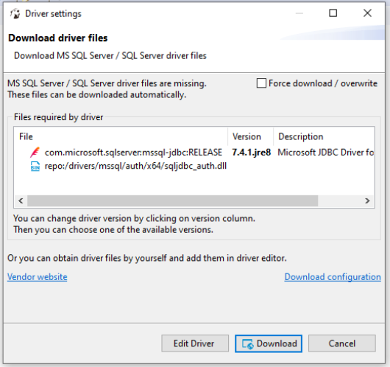

You will have an item named “Sql Server PROD” in the Database Browser tab as below.

In order to make other similar connection FAST, you should copy a connection to many other copies (by right-click and then copy/paste) and then modify them.

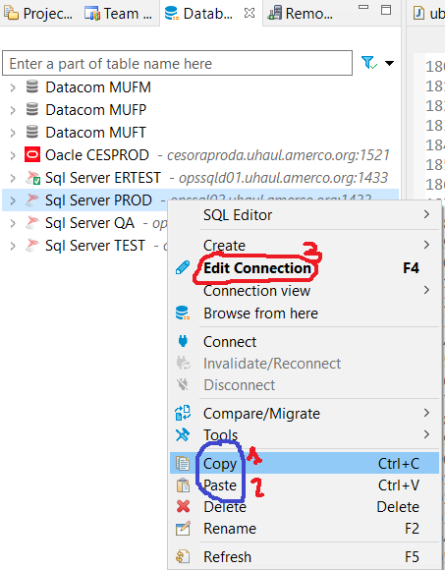 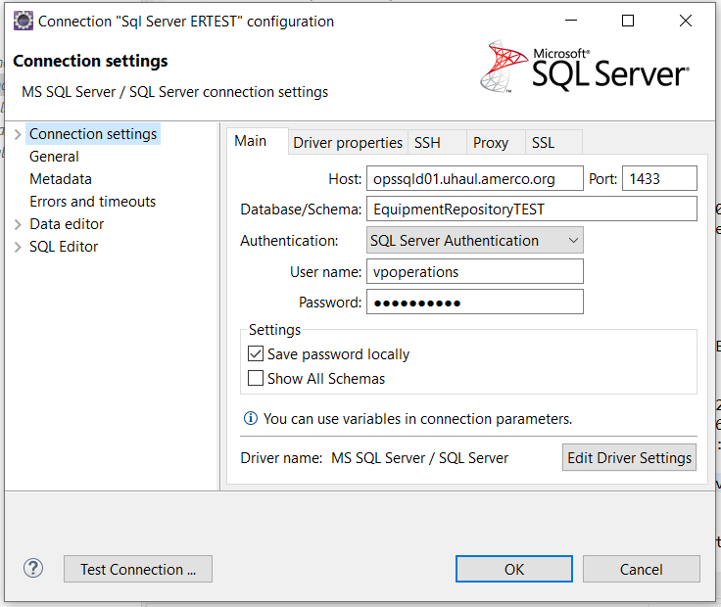

|  |
| --- |
| Connection name (whatever you name): Sql Server ERTEST  Host: **opssqld01.uhaul.amerco.org**  Port: **1433**  Database/Schema: **EquipmentRepositoryTEST**  User name: **vpoperations**  Password: **W7cv89q25x** |

You can copy the connection above to following with little modification:

|  |
| --- |
| Connection name (whatever you name): SQL Server TEST  Database/Schema: **EquipmentRepository** |
| Connection name: SQL Server QA  Database/Schema: **EquipmentRepositoryQA** |

##### Datacom

Datacom is not popular and Dbeaver cannot automatically download its driver, so you have to manually provide Datacom driver “cadcjdbc15.jar” (in the Uhaul jar collection) to Dbeaver.

To install Datacom driver, from Eclipse menu: Database > Driver Manager > New > Add file > open “cadcjdbc15.jar” > Find Class > click on “ca.datacom.jdbc.DatacomJdbcDriver” > enter “Datacom” in Driver Name textbox > OK

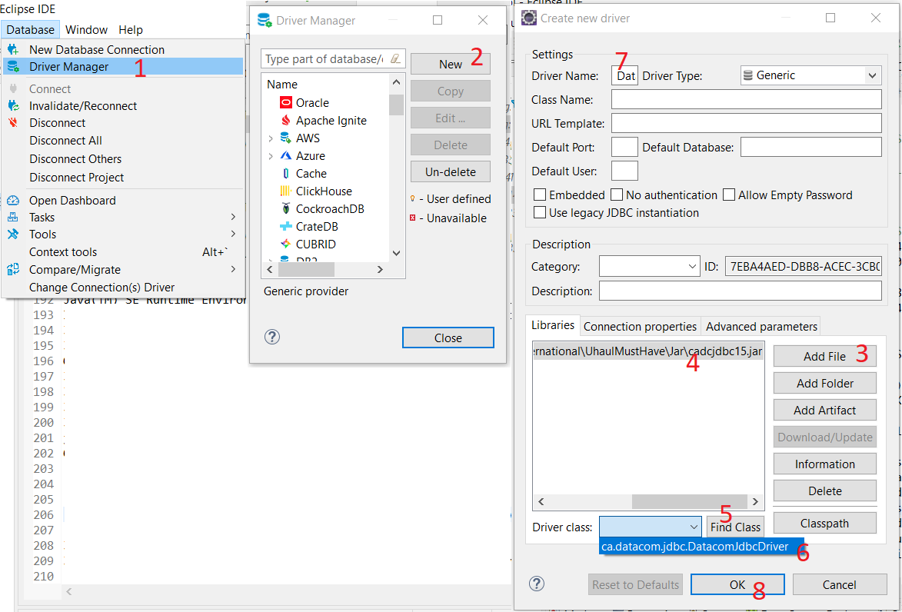

Now having Datacom driver installed, you can create connection to Datacom databases. From the Eclipse menu, choose:

Database > New Database Connection > Datacom > Next > enter JDBC Url and username, password as below > Connection details > enter “Datacom MUFP” at “Connection name” field > Finish > Finish.

|  |
| --- |
| Connection name (whatever you name): **Datacom MUFP**  Host: **jdbc:datacom://mainframe.uhi.amerco:5465/ServerName=DBSRVRP,ApplicationID=CCI3,SystemID=UNIQECC1,HostName=mainframe.uhi.amerco,HostPort=5465,ConnectType=TCP**  Username=**OPERNET**  Password=**+7CW212** |

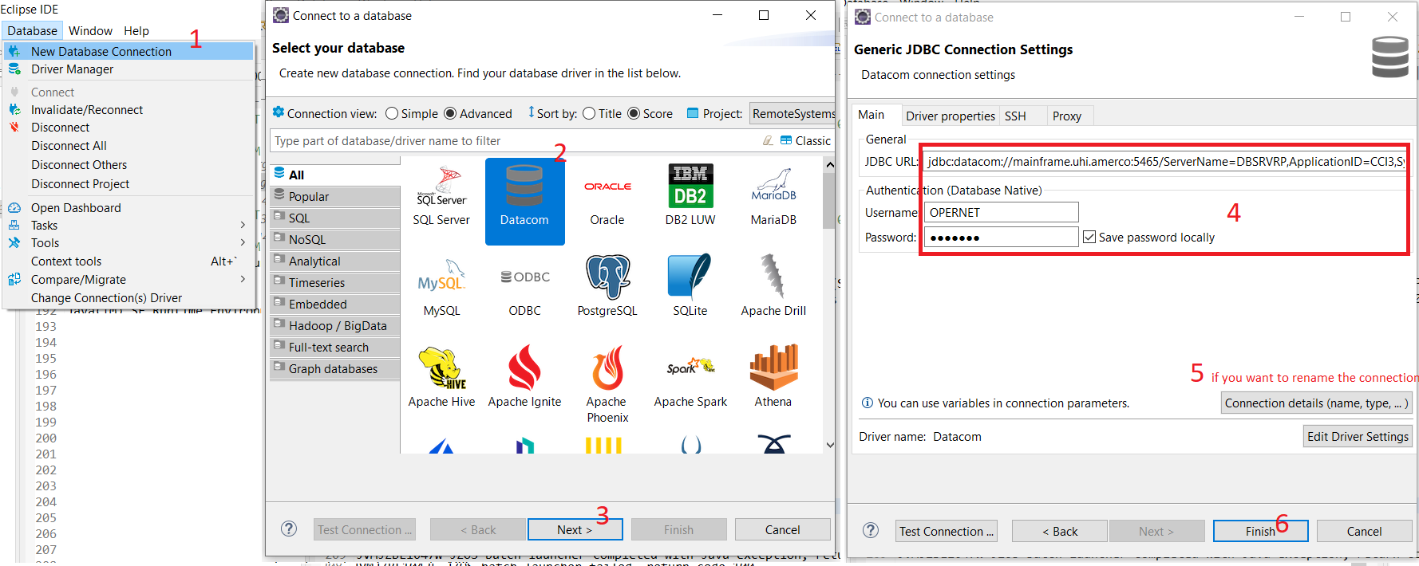

In order to make other similar connection FAST, you should copy a connection to many other copies (by right-click and then copy/paste) and then modify them.

 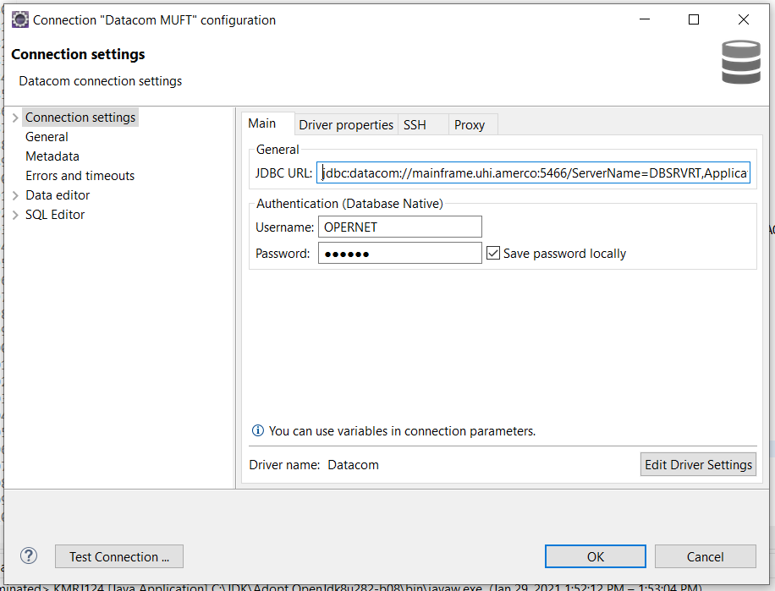

Copy the Datacom MUFP above to the following with little modification:

|  |
| --- |
| Connection name (whatever you name): **Datacom MUFT**  Host = "**jdbc:datacom://mainframe.uhi.amerco:5466/ServerName=DBSRVRT,ApplicationID=CCI0,SystemID=UNIQECC1,HostName=mainframe.uhi.amerco,HostPort=5466,ConnectType=TCP**"  Password=**7CW212** |
| Connection name (whatever you name): **Datacom MUFM**  Host = "**jdbc:datacom://mainframe.uhi.amerco:5464/ServerName=DBSRVRM,ApplicationID=CCI2,SystemID=UNIQECC1,HostName=mainframe.uhi.amerco,HostPort=5464,ConnectType=TCP**"  Password=**7CW212** |

##### Oracle

From Eclipse menu, choose Database > New Database Connection > Oracle > Next

Dbeaver will propose downloading Oracle driver for you, click “Download”.

Enter connection info as below to Host, Database, username, password > Connection details (if you want to rename the connection) > Finish.

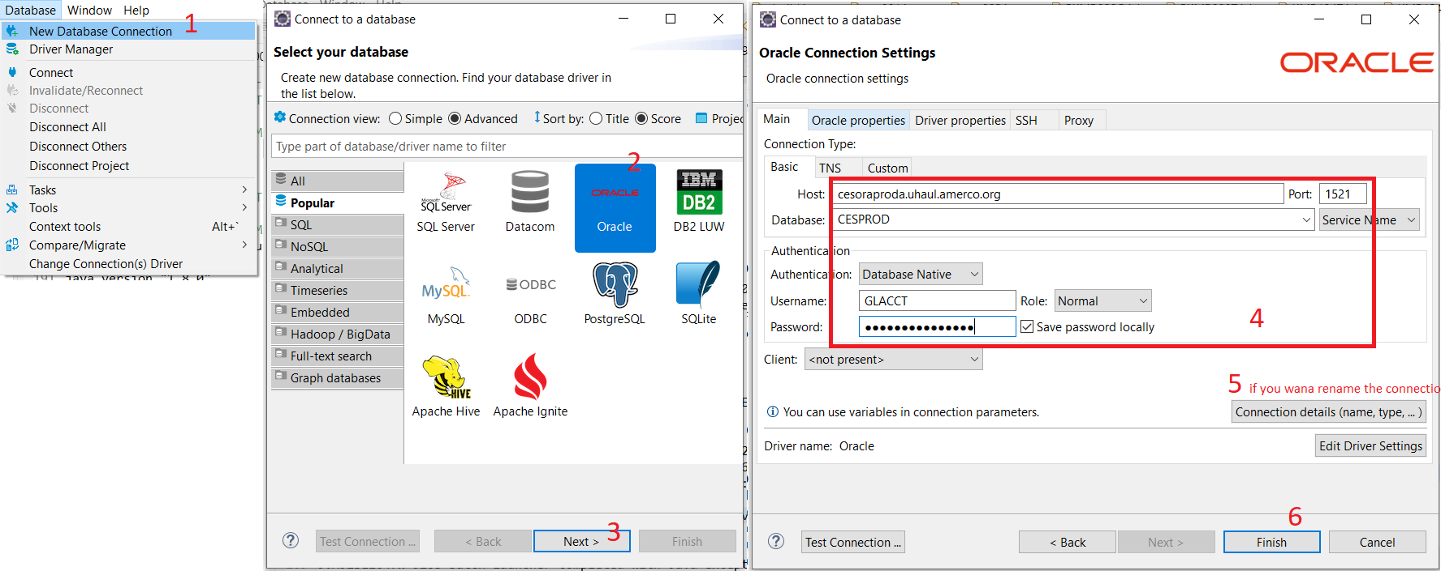

|  |
| --- |
| Connection name (whatever you name): Oracle - CESPROD  host: **cesoraproda.uhaul.amerco.org**  databse: **CESPROD**  username: **GLACCT**  password: **WW_mmwer789** |

#### Running a query/stored procedure and adjust the result view

**Run a query**

To open an editor for typing Sql commands, right-click on the connection in Dbeaver browser tab, and then choose SQL Editor > New Sql Editor.

For a sql command, you can choose a server, a database that you want the command to run against. In the example below, it’s Sql Server ERTEST and database EquipmenRepositoryTEST.

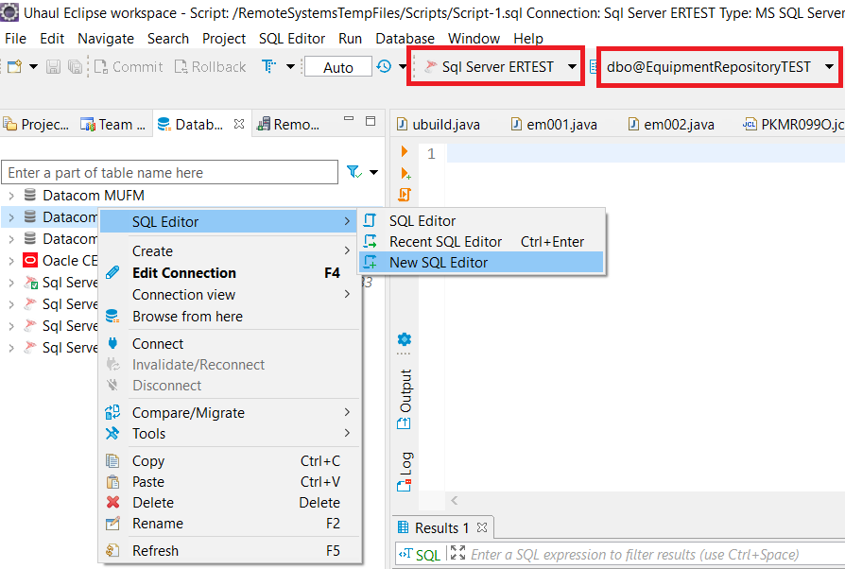

**Adjust the result set view**

For a select query, the result is shown below the Editor.

For a query that calls a stored procedure as below, if you want to see the output during the store procedure, you need to click on 1) and then 2) as below.

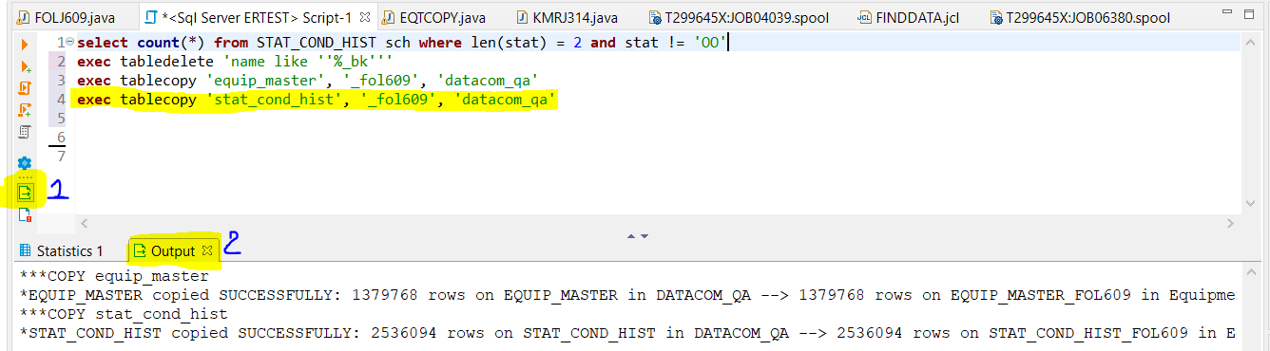

By default, the result set is shown with only 200 rows, if you want to view all rows, click on Setting blue icon and then Global settings (if you want to view all rows for all result set) and then set ResultSet fetch size = 0 as below

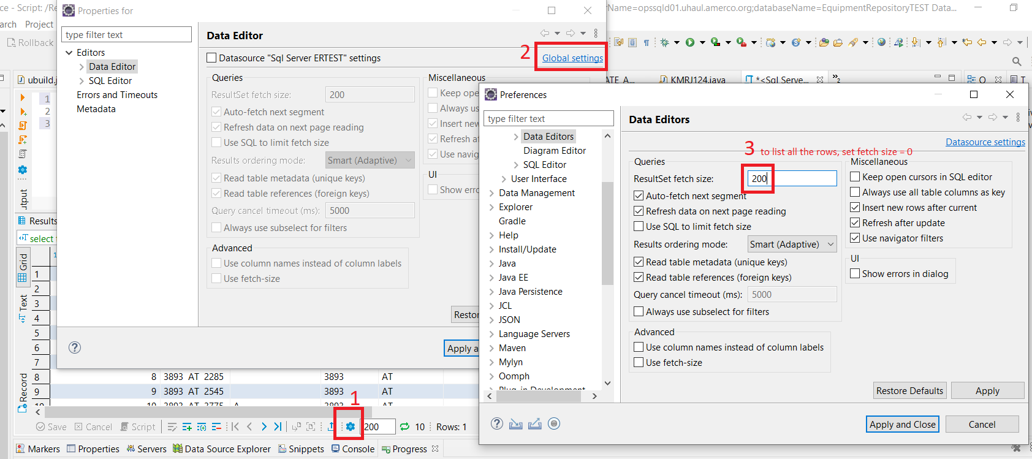

By default, number format uses commas to separate 3 digits, to remove this comma: Windows > Preferences > type “data format” in search box > Data Format > choose Type = Number > uncheck Use Grouping.

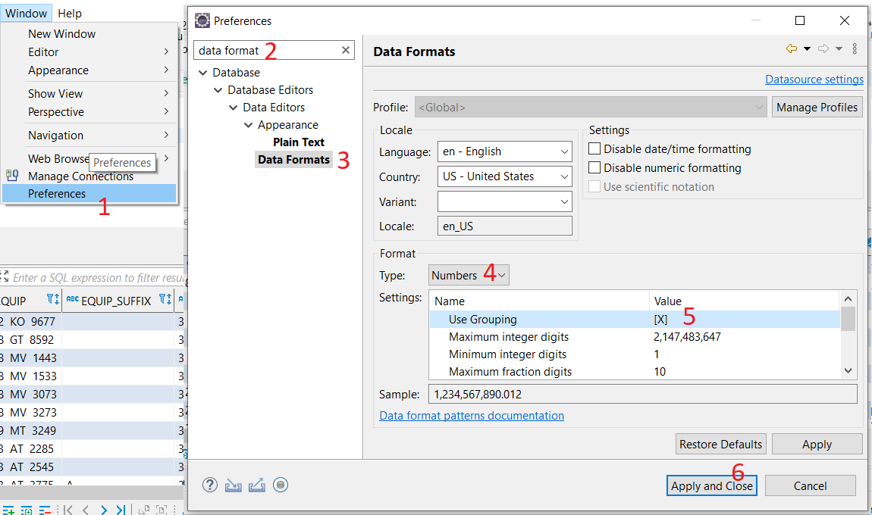

### Where to get database accounts and connection strings?

The database accounts and connection strings used in the above sections can be found in **sqlsrv.java, ora.java, datacom.java** in TFS datasources_development or datasources.

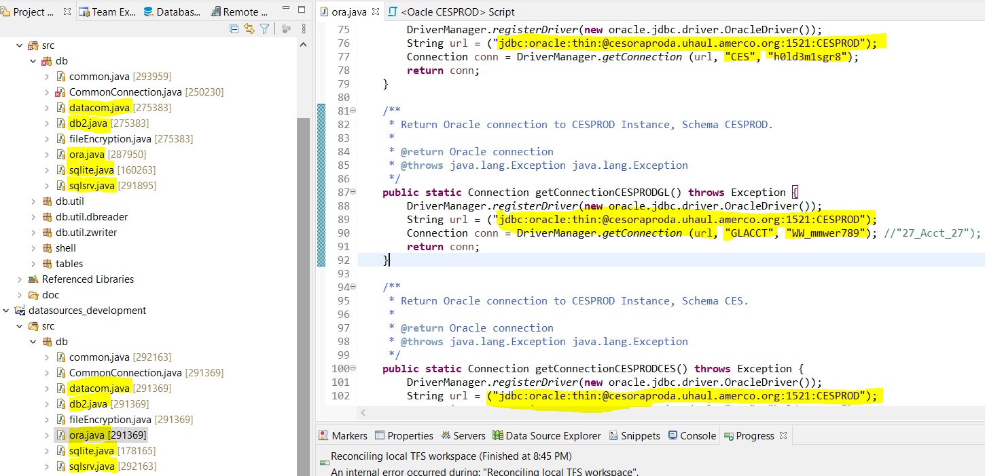

## Step 7 (Optional): Tools to compare, sort files

Programmers often need to compare, sort files.

On the mainframe, **SuperC** is the way to go.

On Windows computers, popular Notepad++ has plugins to compare, sort, and WinMerge is even more powerful for those tasks.

**Notes for WinMerge:**

* To show only difference hiding similarity: choose View > Diff Context > 0 lines
* To sort files before comparison: from either left or right panel, choose Plugins > Scripts > Sort Ascending/Descending

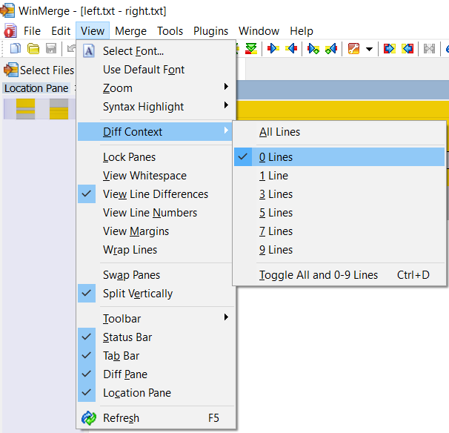 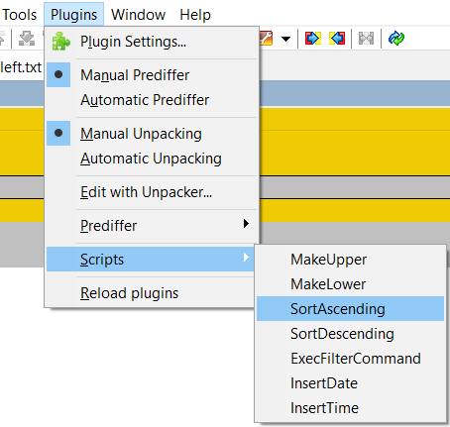

**Notes for Notepad++:**

* To sort a file: choose Edit > Line Operations > Sort Lines Lexicographically Ascending
* To compare 2 files:
  + choose Plugins > Plugin Admin … > Compare
  + open the 2 files you want to compare as two separate tabs; then *Plugins* > *Compare* -> *Compare*

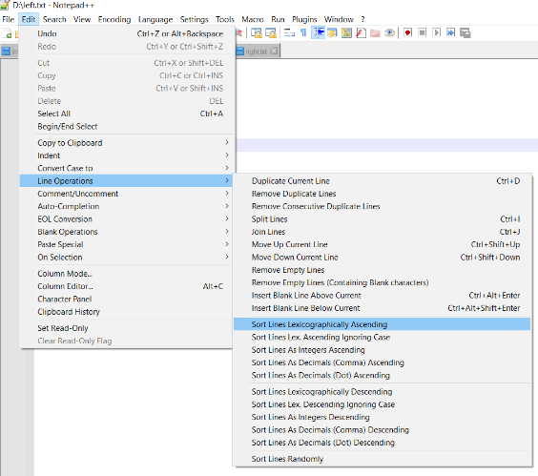 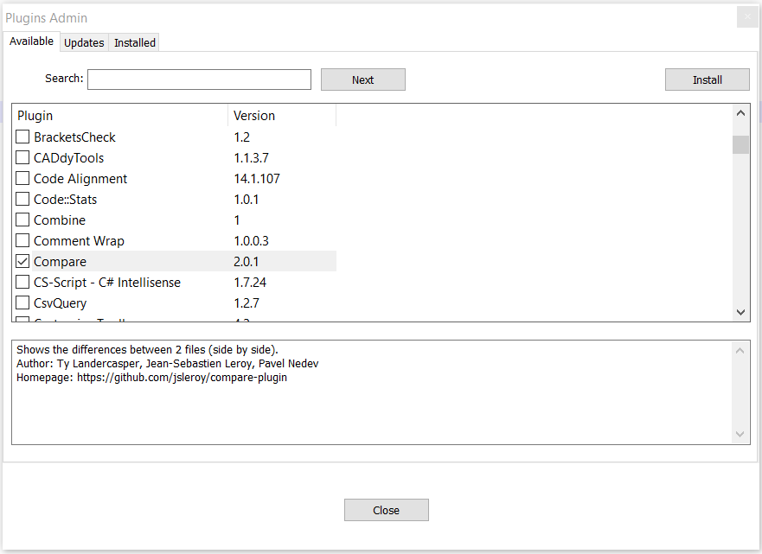 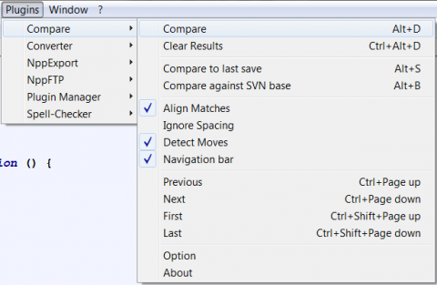

# Section 2: Mainframe basic (…)

# Section 3: Deploy a Java program to mainframe

## Run a Java program on the mainframe (for personal testing)

A Java program runs on the Java Virtual Machine (JVM), which runs only on Unix-like systems and Windows, not the mainframe! However, a Java program can still run on the Mainframe thanks to:

1. The mainframe can run a Unix operating system parallel to the z/OS.
2. The mainframe has some utilities (BPXBATCH, JZOS, JAVAPROC) that can call Unix programs and even redirect the stdin, stdout, stderr of a Unix process to the mainframe’s MVS filesystem.

So, for a Java program to run on the mainframe, we need to:

* Upload the Java program to the mainframe’s Unix filesystem (1)
* Write a JCL that uses a utility to call the Java program (2)

The utility we use here is JAVAPROC, it requires two parameters:

* The name of the Java class that we want to run
* A shell script that prepares environment variables for JVM to launch a Java program (3)

The following presents (1), (3), (2)

### Step 1: upload the Java program to the mainframe’s Unix filesystem

#### Exporting a Java program to the runnable JAR format

When the program is ready to be tested on Mainframe, you will first need to export the program to the runnable Jar format:

* Right-Click the Package of the program > Export

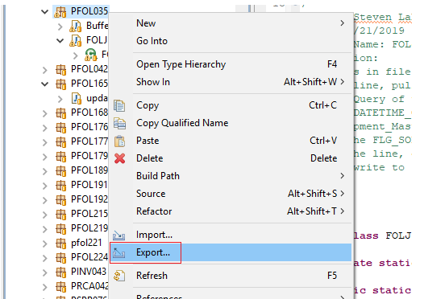

* Select “Runnable JAR file” > Next > Select the appropriate “Launch configuration” and any location **locally** for the JAR > Finish

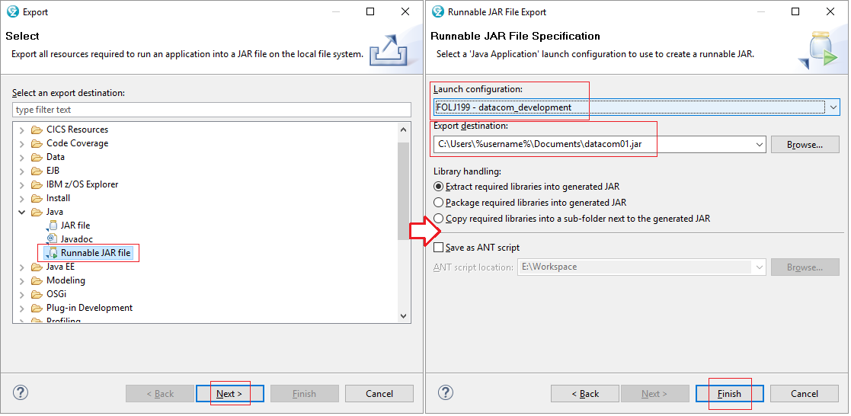

#### Copy the JAR file to the mainframe’s Unix filesystem

First you need a personal folder on the mainframe’s Unix system to contain your JAR file. If you don’t have such a folder on Unix, create one by:

* Connect to the Mainframe in the “Remote System” tab,
* Browse to “/z/OS UNIX Files/My Home/HOME/” folder.
* Right-Click on “HOME” > New > Folder > Name it your T#

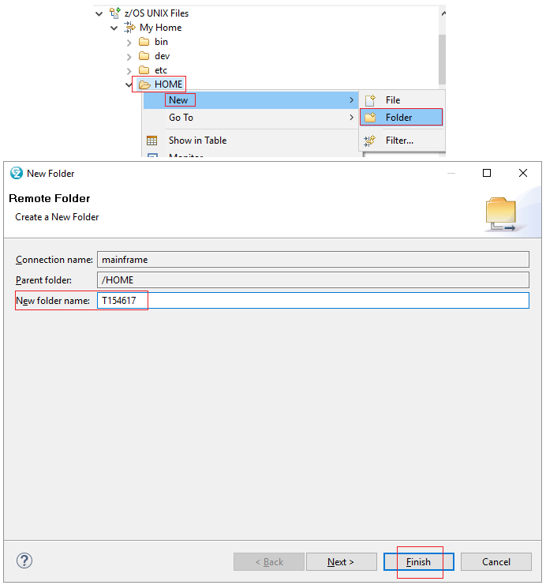

Now that the folder is created, go to your local files and copy the JAR file from your local drive to the mainframe’s Unix folder (the one we just created named your T#). We will do this by dragging the file from Windows Explorer and dropping the file into the “Remote Systems” view.

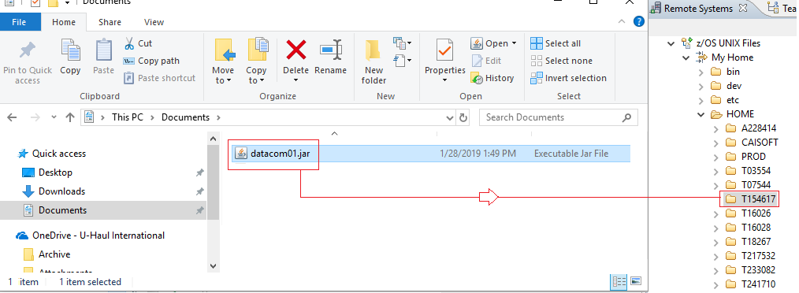

### Step 2: create a shell script that prepare environment variables for JVM to launch the Java program

The following is a sample of a shell script that set up environment variables needed for a JVM:

* JAVA_HOME: the path to the JDK
* APP_HOME: the path to the Java program jar
* CLASSPATH: the path to external library that the Java program needs
* Other environment variables like encoding, etc

|  |
| --- |
| # This is a shell script which configures any environment variables for the Java JVM.  # Variables must be exported to be seen by the launcher.  #. /etc/profile  export JAVA_HOME=/java80/J8.0_64  export PATH=/bin:"${JAVA_HOME}"/bin  LIBPATH=/lib:/usr/lib:"${JAVA_HOME}"/bin  LIBPATH="$LIBPATH":"${JAVA_HOME}"/lib/s390x  LIBPATH="$LIBPATH":"${JAVA_HOME}"/lib/s390x/j9vm  LIBPATH="$LIBPATH":"${JAVA_HOME}"/bin/classic  export LIBPATH="$LIBPATH":  echo "Using Java 8 jvm"  # Customize your CLASSPATH here  APP_HOME=/HOME/**T#######**/**JAR_NAME**.jar  CLASSPATH=$APP_HOME:"${JAVA_HOME}"/lib:"${JAVA_HOME}"/lib/ext  # Add Application required jars to end of CLASSPATH  #for i in "${APP_HOME}"/*.jar; do  # CLASSPATH="$CLASSPATH":"$i"  # done  export CLASSPATH="$CLASSPATH":  # Set JZOS specific options  # Use this variable to specify encoding for DD STDOUT and STDERR  #export JZOS_OUTPUT_ENCODING=Cp1047  # Use this variable to prevent JZOS from handling MVS operator commands  #export JZOS_ENABLE_MVS_COMMANDS=false  # Use this variable to supply additional arguments to main  #export JZOS_MAIN_ARGS=""  # Configure JVM options  #IJO="-Xms16m -Xmx128m"  #IJO="-XX:MetaSpaceSize=16m -XX:MaxMetaSpaceSize=256m"  # Uncomment the following to aid in debugging "Class Not Found" problems  #IJO="$IJO -verbose:class"  # Uncomment the following if you want to run with Ascii file encoding..  #IJO="$IJO -Dfile.encoding=ISO8859-1"  export IBM_JAVA_OPTIONS="$IJO " |

In the following we create a shell script named “JAVA001” to set up a JVM for our Java program.

Since we might want different shell scripts for different Java programs, we create a folder named “JAVAENV” under our T-account folder on the mainframe to contain all the future shell scripts, so “JAVA001” is just for now, and we will probably have “JAVA002”, “JAVA003” in the future.

To create a folder, i.e. PDS, on the mainframe:

* In Remote System’s z/OS tab, connect to the Mainframe
* Right-Click “MVS Files” > New > Allocated Partitioned Data Set
* Under “Data set name:”, enter “JAVAENV” in the blank field to the right of your T# > Next > Finish

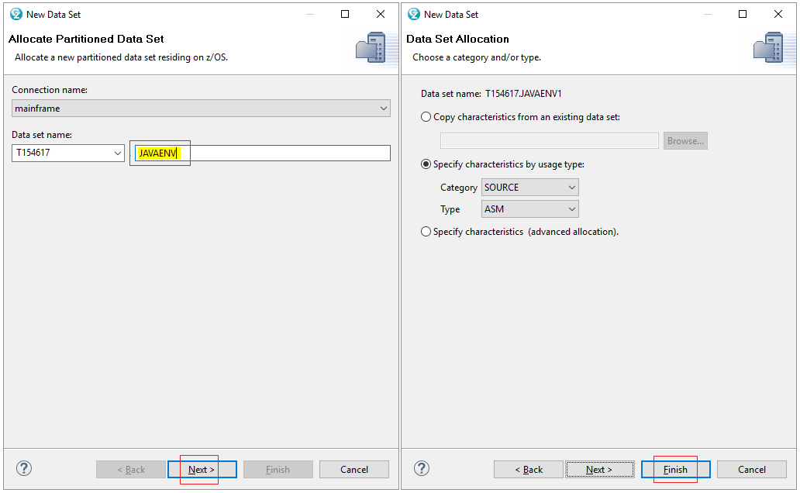

Now copy the shell script sample above to a file called “JAVA001” or whatever you name it (make reference of the name since it will be called in the JCL):

* Navigate to MVS Files > My Data Sets > JAVAENV
* Right-Click on JAVAENV > New > Create Member…

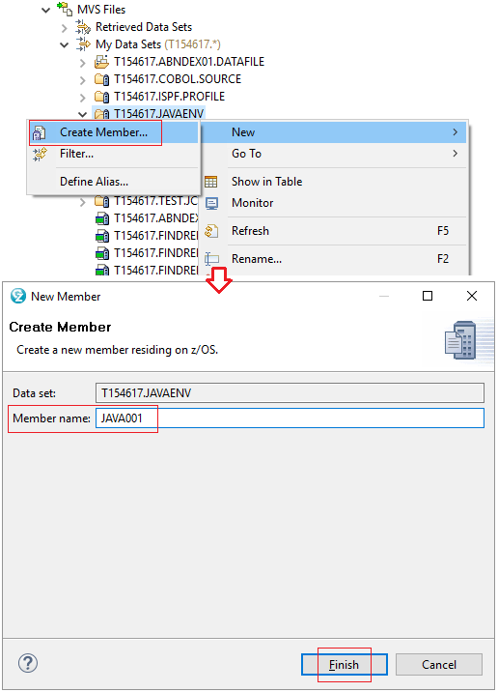

* Double-Click on the file “JAVA001” and copy the following (replacing the data that is in red with your data):

### Step 3: write a JCL to call the Java program with the prepared JVM configuration

Example 1: a JCL for a Java program that:

* read an input file, described by INPUT dd,
* write out an output file, described by OUT_NAME dd

Also we want to run this Java program many times, and for each time, we want to delete the output file we have from the last run.

|  |
| --- |
| //*EXAMPLE OF DELETING A FILE, “PATH_TO_OUTPUT_FILE”  //*THEN SPECIFYING THE JAVA PROGRAM TO RUN  //*THEN SPECIFYING JAVA ENVIRONMENT PATH  //*THEN SPECIFYING INPUT FILE TO READ  //*THEN SPECIFYING OUTPUT FILE IN WHICH TO WRITE  //**T#######** JOB (1100,PROD,0720,1000,0000,,01,Y,000),  // '**YOUR_NAME**',CLASS=G,MSGCLASS=X,REGION=0M  //*  //PROCLIB JCLLIB ORDER= **T#######**.TEST.JCL  //* DISP=SHR  //* DD DSN=PZ2K.LOADLIB.BATCH,  //* DISP=SHR  //* DD DSN=PROD.LOADLIB.BATCH,  //* DISP=SHR  //*  //*---------------------------------------------------------------------  //JS005 EXEC PGM=IEFBR14  //DD1 DD DSN= **PATH_TO_OUTPUT_FILE**,  // DISP=(MOD,DELETE,DELETE),  // SPACE=(TRK,0)  //JS010 EXEC JAVAPROC,  // VERSION='86',  // JAVACLS='**JAVA_PACKAGE_NAME**. **JAVA_CLASS_NAME**',  // ARGS='test args',  // TIME=NOLIMIT  //*JAVA PATH CREATED PREVIOUSLY:  //STDENV DD DSN= **T#######.JAVA_ENV_PATH(ENV_MEMBER_NAME)**,  // SUBSYS=LAM,  // DISP=SHR  //*”INPUT” AND “OUT_NAME” ARE THE NAMES TO REFERENCE  //*IN YOUR JAVA PROGRAM – INPUT CAN BE CALLED INPUT  //*BUT OUT_NAME CAN BE ANYTHING EXCEPT “OUTPUT”  //**INPUT** DD DSN= **PATH_TO_INPUT_FILE**,  // DISP=SHR  //**OUT_NAME** DD DSN= **PATH_TO_OUTPUT_FILE**,  // DISP=(NEW,CATLG,DELETE),  // DCB=(RECFM=FB,LRECL=171,BLKSIZE=0),  // UNIT=WORK,  // SPACE=(CYL,(30,15),RLSE)  //*-------------------------------------------------------------------- |

Note that the JVM configuration (JAVA001) needs to match JCL (FOLJ199.jcl)

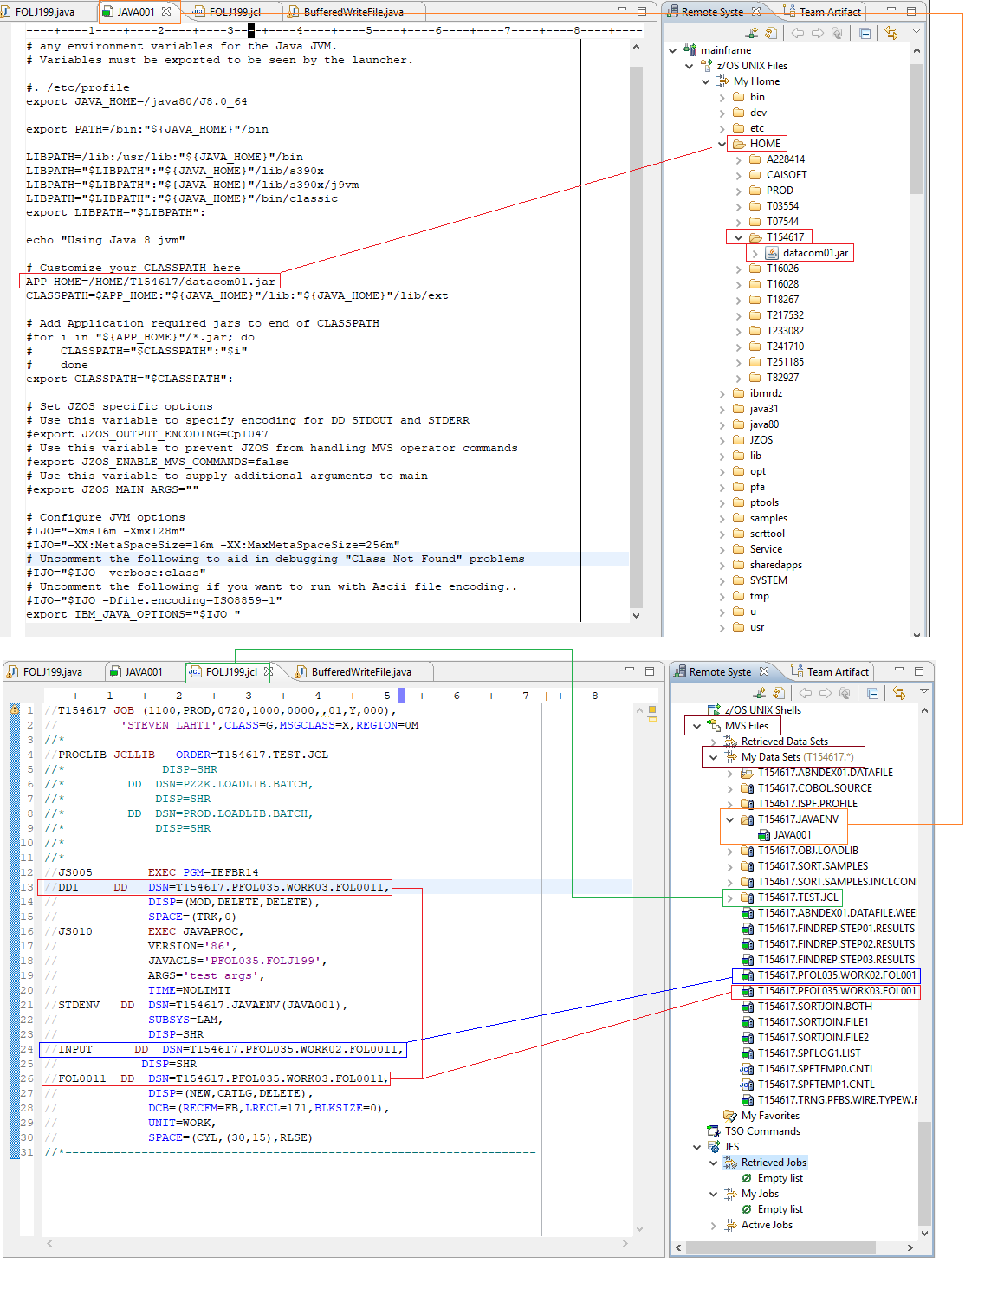

Example 2:

|  |
| --- |
| //T299645X JOB (2144,TEST,0050,0050,0000,,01,Y,60,00,064,OWL0,####),  // 'Thang Tran',CLASS=J,MSGCLASS=X,REGION=0M  //*---------------------------------------------------------------------  //* Delete the output of the previous run  //*---------------------------------------------------------------------  //JS1 EXEC PGM=IEFBR14  //DD1 DD DSN=T299645.PKMR147.KMRP312.OUT.T,  // DISP=(MOD,DELETE,DELETE),  // SPACE=(TRK,0)  //*---------------------------------------------------------------------  //* Call the Java program  //*---------------------------------------------------------------------  //JS3 EXEC JAVAPROC,  // JAVACLS=PKMR147.KMRJ312,  // TIME=1439  //STDENV DD DSN=T299645.CONFIG.JVM,  // DISP=(SHR,KEEP,KEEP)  //INPUT DD DSN=T299645.PKMR147.KMRP312.INPUT.O,  // DISP=SHR  //OUTPUT1 DD DSN=T299645.PKMR147.KMRP312.OUT.T,  // DCB=(RECFM=FB,LRECL=204,BLKSIZE=0),  // UNIT=TEST,  // DISP=(NEW,CATLG,DELETE),  // SPACE=(TRK,(150,90),RLSE)  //*---------------------------------------------------------------  //* DELETE OUT FILES IF STEP JS3 DOES NOT RETURN CONDITION CODE OF 0.  //*---------------------------------------------------------------  //JS3D EXEC PGM=IEFBR14,  // COND=(0,EQ,JS3.JAVAJVM)  //DD1 DD DSN=T299645.PKMR147.KMRP312.OUT.T,  // DISP=(MOD,DELETE,DELETE)  //*---------------------------------------------------------------  //* FORCE ABEND IF STEP JS3 DOES NOT RETURN CONDITION CODE OF 0.  //*---------------------------------------------------------------  //JS3A EXEC JCLERROR,  // COND=(0,EQ,JS3.JAVAJVM)  //* |

### Step 4: run the JCL

First open the JCL you have written: in Remote System tab, navigate into Mainframe > MVS Files > My Data Sets > “T######.TEST.JCL” and double-click) the jcl file to open it.

When the file is open, you will want to right-click > Submit > MAINFRAME. This will put the job into queue to run on Mainframe (JES).

## Process to replace Ideal by Java programs on mainframe’s production

### Step 1: get tester’s approval

In the migration project, your Java program (against SQL server) is supposed to produce an output that matches the output of Ideal program (against Datacom).

The tester (Bob) will run the 2 programs against:

* SQL ERTEST – MUFT for a quick test
* SQL QA – MUFM or SQL PROD – MUFP for a full test
* Customized data if you and tester think the test needs

and compare the output. You get the tester’s approval when the comparison is 100% match.

Note that SQL ERTEST – MUFT probably doesn’t have enough data, and SQL QA - MUFM or SQL PROD – MUFP probably are not in sync.

### Step 2: get user’s approval

After having tester’s approval, notify Frances (manager) so that she will send the output of Java - Ideal programs to the user of the program. While waiting for the user to approve, you can do step 3 (rewrite JCL) but don’t do step 4 yet (submit the source code to TFS production).

### Step 3: rewrite JCL (log it out, rewrite, get approval, log it in)

The JCL need to be updated to reflect the change to your Java program. To do this, you need:

* Logout the JCL. The term “logout” in this context means moving the JCL out of PROD.LIBR.JOBLIB(…) to TEST.LIBR.JOBLIB(…) and hence others cannot take it to modify.
* Copy the JCL from TEST.LIBR.JOBLIB(…) to your T-folder and modify it
* Show the rewritten JCL to JCL checker and get their approval.
* Login the rewritten JCL

#### Step 3.1: Logout the JCL

Enter command **e.c** (which takes you to “CCF – LIBRARIAN Change Control Facility)

Enter *4* for “LOGOUT”

Enter your “Work Order ID” in the Field “REQUEST ID = = = >”

Hint: If you Enter 3 at step ii, then F3 to go back then enter 4, it will fill in the ID for you

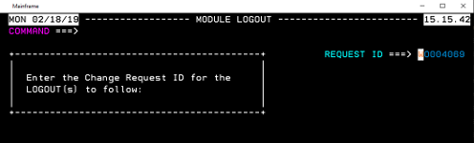

Note: If you do not have or know your “WO” number, please see Work Order ID

Enter the following:

MODULE: [JCL Filename]

PRODUCTION MASTER FILE: *5* (for PROD.LIBR.JOBLIB)

Note: Use F7/F8 to locate the needed “AVAILABLE FILES”

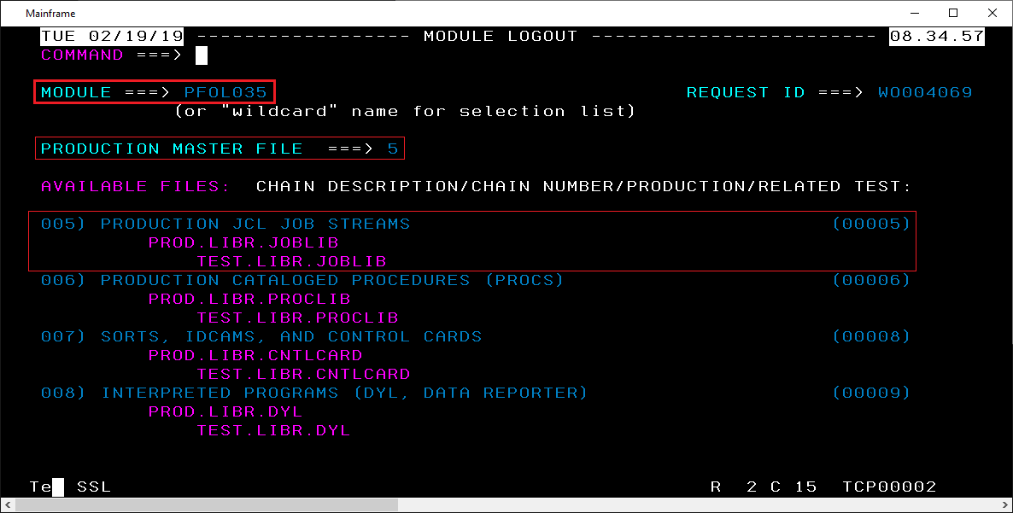

Note: If the “HISTORY CREATE/MODIFY” appears, then the file does not exist that was entered … It should display “Movement Complete”

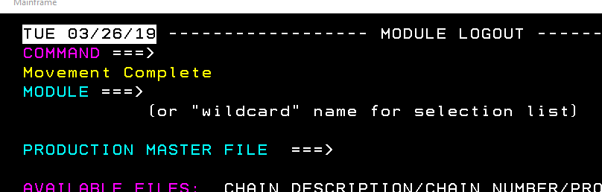

You can then hit “F3” to back-out of the Module Logout screen

#### Step 3.2: Copy the JCL from TEST.LIBR.JOBLIB(…) to your T-folder

Be sure the path exists to where you want to copy it

Enter command **e.u** (which takes you to the “UTILITY” – ELIPS copy/move UTILITY”)

OPTION: C Copy command

DATA SET NAME: [name of the JCL]

e.g.: TEST.LIBR.JOBLIB(PFOL035)

Enter your T path with the name of the JCL

DATA SET NAME: [T######.[group].[type](member_name)

e.g.: ’T154617.PGM.JCL(FOLP035)’

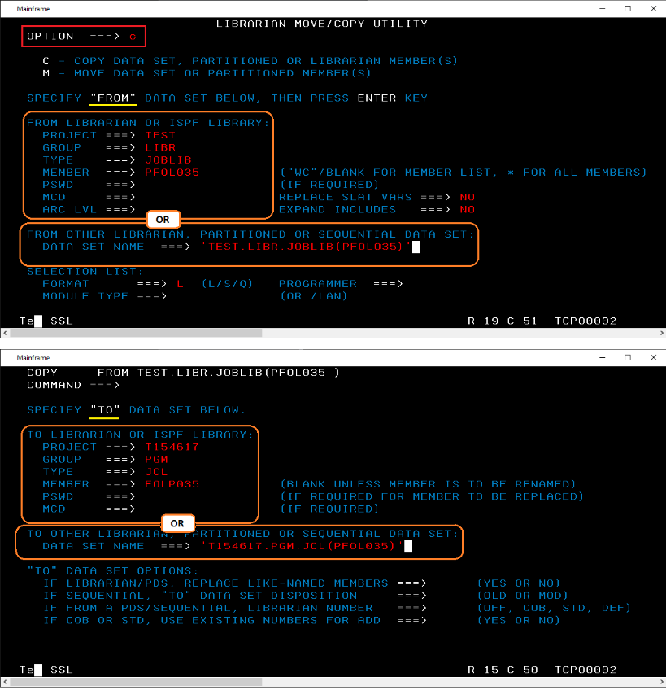

#### Step 3.3: Modify the JCL

There are several things you need to modify in the JCL:

**Modify the job card**

At the beginning of the JCL is what is called the Job Card which is basically information about the Job and certain settings. **Be sure to change the “Region” of the Job Card (the header of the JCL) to 0M.**

|  |
| --- |
| //PFOL### JOB (1100, PROD, 0720, 1000, 0000, , 01 , Y, 000),  // ‘OPERATIONS’ ,CLASS = U, MSGCLASS=R,  // **REGION=0M** |

**Add configuration for Java**

|  |
| --- |
| //**JS###** EXEC JAVAPROC,  // JAVACLS=**'JAVAPACKAGE.JAVACLASS'**,  // TIME=1439  //STDENV DD DSN=PROD.LIBR.CNTLCARD(JAVA0002),  // SUBSYS=LAM,  // DISP=SHR |

**Add a step for the case the job abend**

Be sure that your JCL has another couple of steps following to return the error code and delete anything created if the job abends.

|  |
| --- |
| //*---------------------------------------------------------------  //* DELETE OUT FILES IF STEP JS### DOES NOT RETURN CONDITION CODE OF 0.  //*---------------------------------------------------------------  //JS###D **EXEC** PGM=IEFBR14,  // COND=(0,EQ,JS###.JAVAJVM)  //DD1 DD DSN=**PATH_TO_OUTPUT_FILE,**  // DISP=(MOD,DELETE,DELETE)  //*  //*---------------------------------------------------------------  //* FORCE ABEND IF STEP JS### DOES NOT RETURN CONDITION CODE OF 0.  //*---------------------------------------------------------------  //JS###A **EXEC** JCLERROR,  // COND=(0,EQ,JS###.JAVAJVM)  //* |

Where “JS###” is the Step of the JCL for your program. “JS###D” is the Deletion Step and “JS###E” is the Error step to force and Abend. D and E will both execute if the status code of your Java is not “0”.

#### Step 3.4: Copy the rewritten JCL from your T-folder to TEST.LIBR.JOBLIB(…) and Get approval

Copy the rewritten JCL from your T-folder to TEST.LIBR.JOBLIB(…) and make a work request for Andrei Kourt to check if the JCL works. With his approval, move to the next step.

To copy your current JCL to TEST.LIBR.JOBLIB(…):

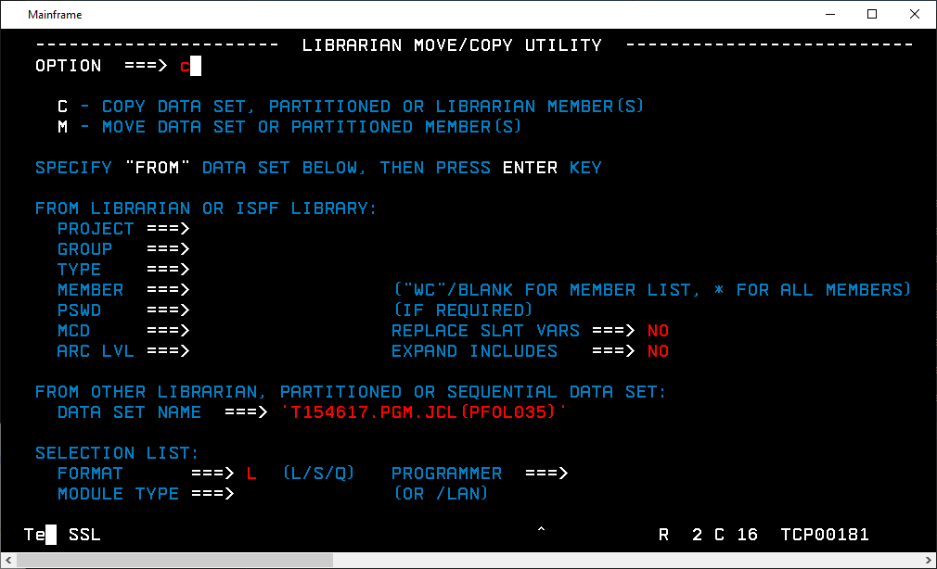

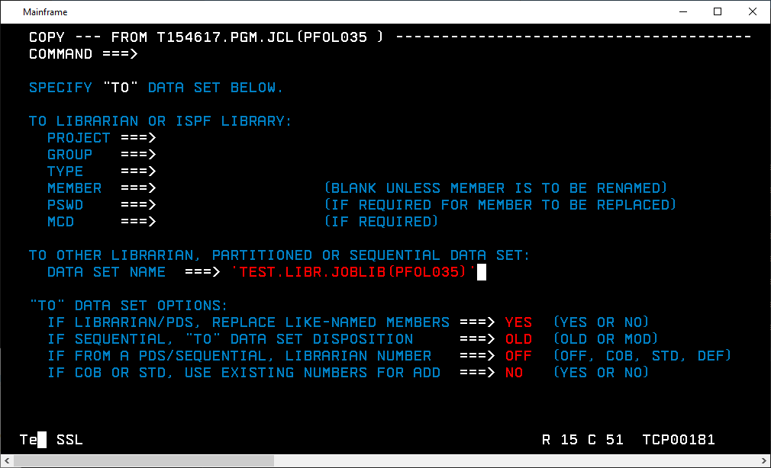

Note: You can check your copy by navigating to “E.E” in SPSF > Enter in

PROJECT: TEST

GROUP: LIBR

TYPE: JOBLIB

MEMBER: [Name of JCL/Job]

#### Step 3.5: Login the rewritten JCL

As before, navigate to **e.c** (CCF) > option 5 for “LOGIN”

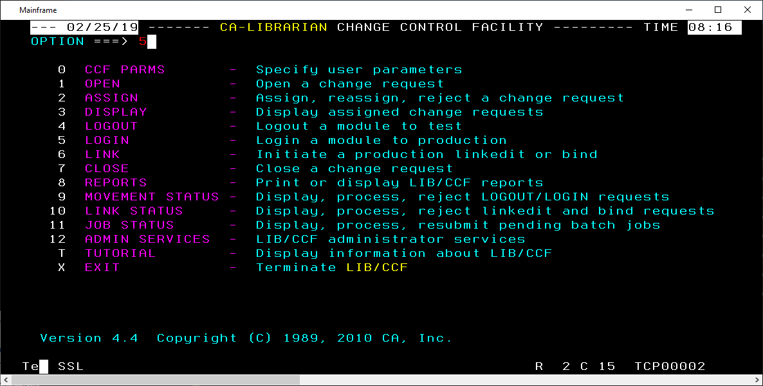

Enter “P” followed by the appropriate logged-out module

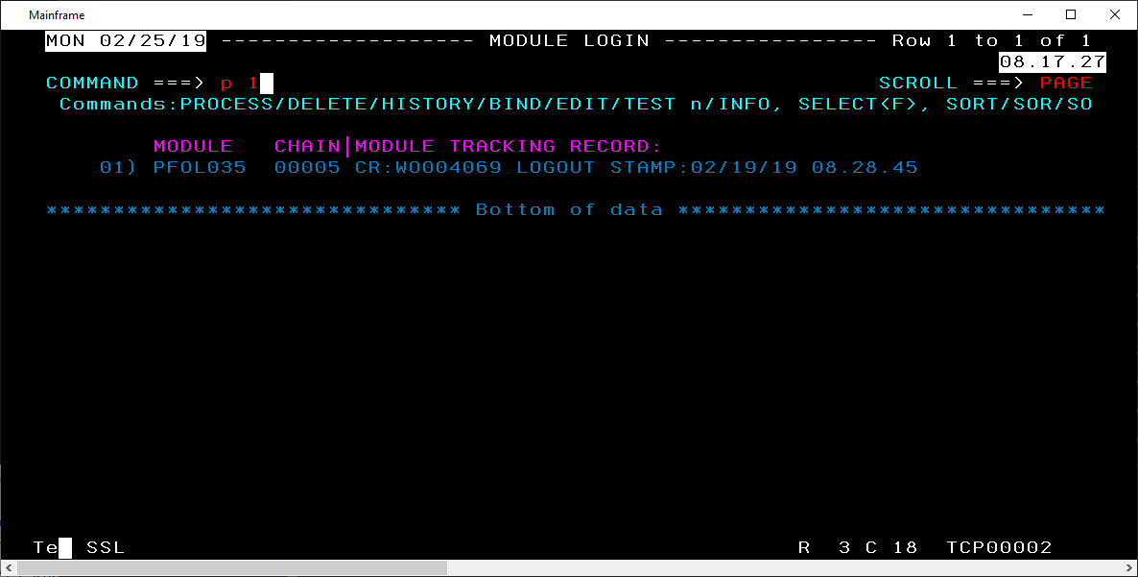

Enter a DESCRIPTION OF CHANGES (“Rewrite of Datacom to Java”, as well as more descriptive details)

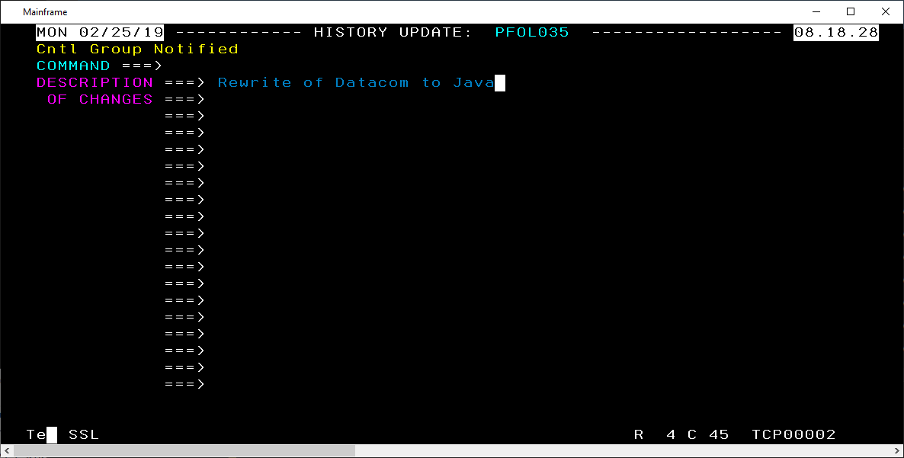

After hitting [Enter], you should see “Entry processed” in the upper-left

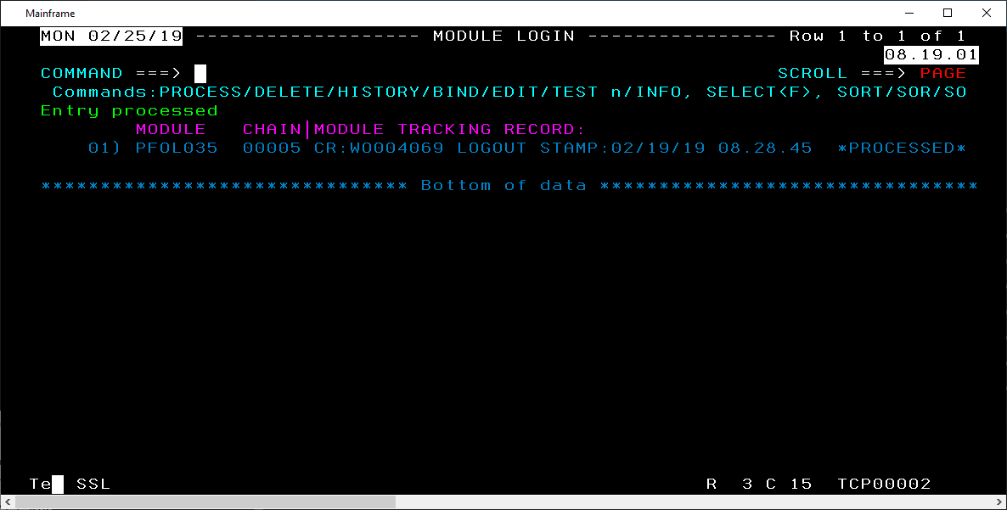

Note: If you F3 back to the options and click again on “LOGOUT”, that module should no longer be listed.

### Step 4: submit Java source code to TFS’s production repos

You commit changes of your code to TFS’s development repos and ask Todd Nicholson to move your code from the development repos to the TFS PRODUCTION repos.

In the request email, you should include: [Package] [Java class name(s)]

### Step 5: submit traveler form to the manager

Fill in the traveler form in which you should explain that you write a Java program and rewrite a JCL. Also include the work item ID and your phone number.

Email Frances and MichaelR. Frances will put the user’s approval into the form, and then you forward her email with the user’s approval to MichaelR. After Mike’s signature, the form will be forwarded to Lydia, who eventually places the JCL into PRODUCTION, and when the JCL is executed, it will call your Java program.

Your Java program is officially used in Production!

### Step 6: document what your program does in APCDOC

From the SPSF menu, enter “K” followed by [Enter]

Enter “A” then [Enter]

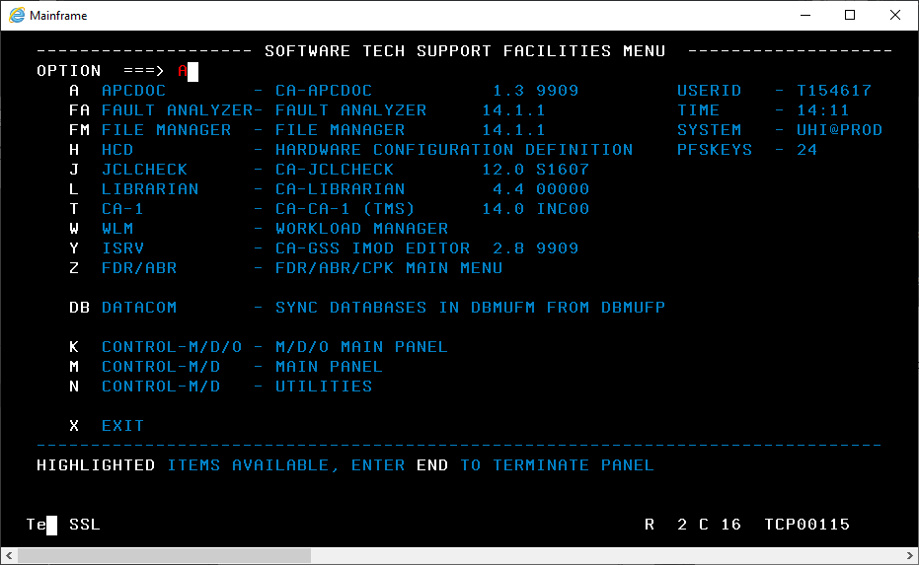

Enter “2” for “DOCUMENTATION”, [Enter]

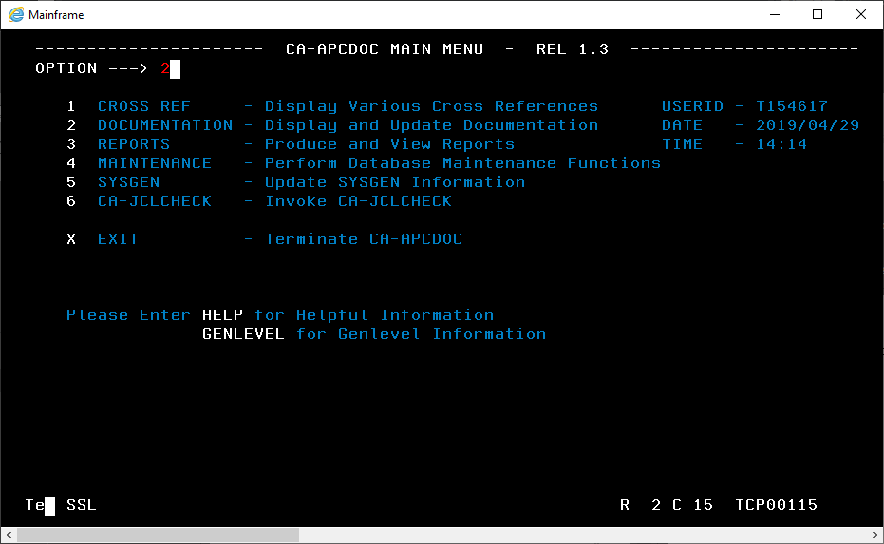

Type “S” besides “PROGRAM” > [Enter]

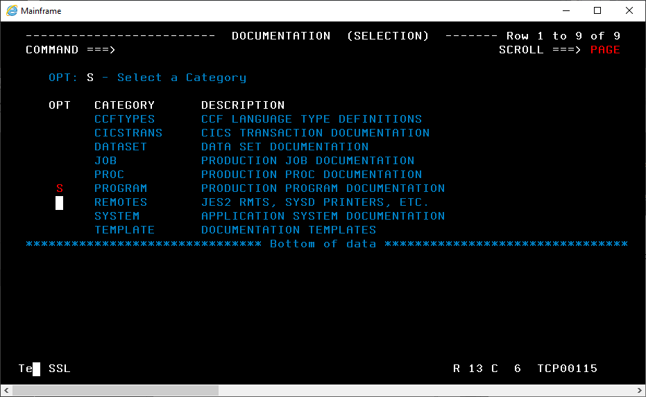

Enter “E” (for Edit) in the “OPTION” field and tab twice down to “PROGRAM Name ==>” and enter the program name. Then enter “S” besides “ABSTRACT”

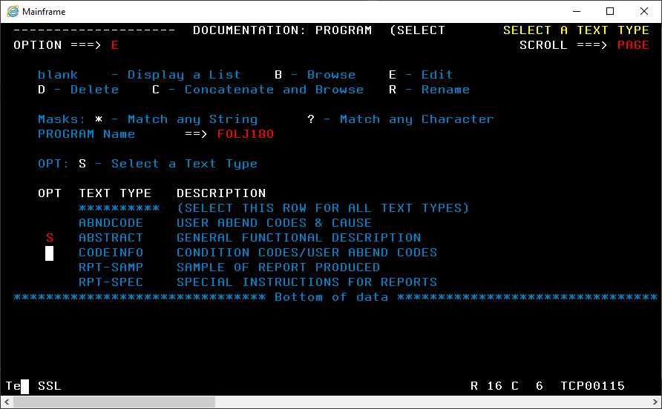

Enter in a description of the program (your description in java should be fine)

Hit [Enter] when done then

Hit [Home] to focus on the “COMMAND” field

Enter “SAVE” then [Enter]

It should now state “DOCUMENTATION SAVED” in the upper-right

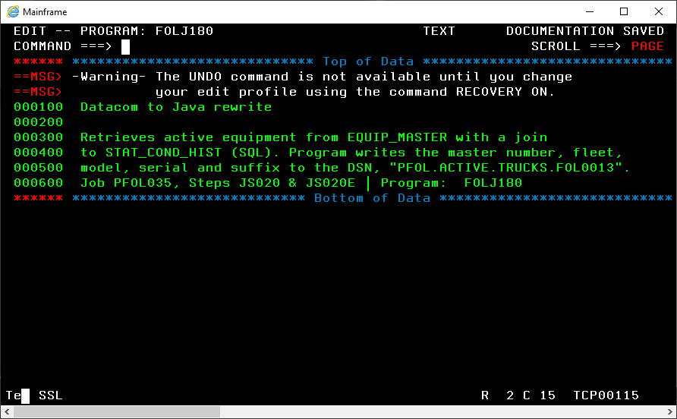

Note: If you would like to view the documentation you just submitted, you can do so by repeating step “E” above and entering “B” (for browse) in the “OPTION” field rather than “E”. Of course, this only works after you have submitted documentation first.

# Section 4: Azure DevOps - Boards and Repos

## What is Azure DevOps?

### Overview of services in Azure DevOps

Microsoft’s description for its Azure DevOps product:

Azure DevOps is a bunch of services for support **teams** to plan work, collaborate on code development, and build and deploy applications. Azure DevOps includes:

* 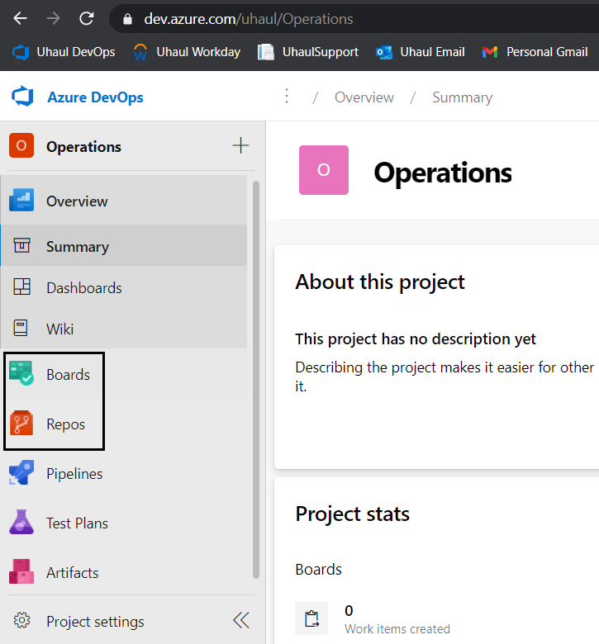**Azure Boards** delivers a suite of Agile tools to support planning and tracking work, code defects, and issues using Kanban and Scrum methods.
* **Azure Repos** provides Git repositories or Team Foundation Version Control (TFVC) for source control of your code.
* **Azure Pipelines** provides build and release services to support continuous integration and delivery of your applications.
* **Azure Test Plans** provides several tools to test your apps, including manual/exploratory testing and continuous testing.
* **Azure Artifacts** allows teams to share packages such as Maven, npm, NuGet, and more from public and private sources and integrate package sharing into your pipelines.

Other collaboration tools:

* **Dashboards**: Customizable team dashboards with configurable widgets to share info, progress, and trends
* **Wikis**: Built-in wikis for sharing information

This documentation focuses on only what Java developers do at Uhaul: Azure Boards (work tracking) and Azure Repos (TFS source code control).

**TFS is just a part of Azure DevOps and please Don’t call Azure Boards as TFS.**

### First glance at Uhaul’s Azure DevOps for Java developers

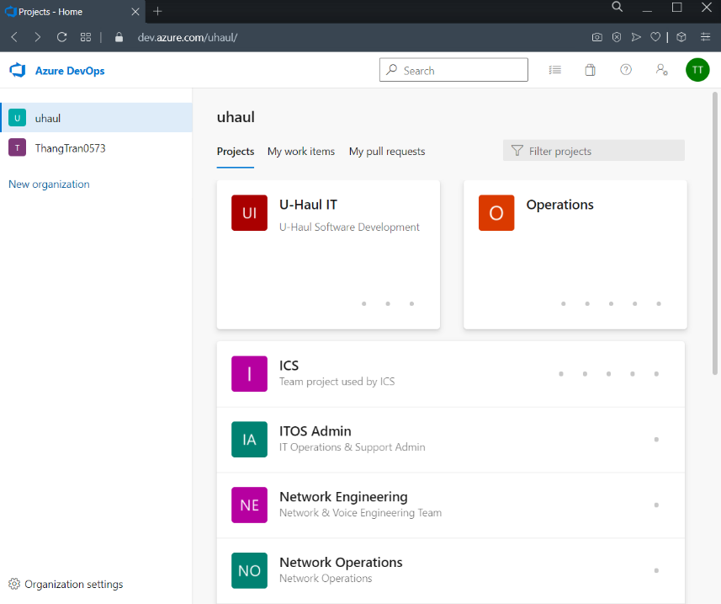Log in to <https://dev.azure.com/uhaul/>, you have two “organization” as shown on the left panel:

* **YourNameXYZT**: your personal “organization” where you can create and manage your own projects.
* **uhaul**: in this organization, unless you’re a manager, you don’t have the right to create, manage a project. As a Java developer, you will work with 2 projects established at Uhaul:
  + **U-Haul IT**: this project is for managing work of Uhaul Software Development Department; it is not associated with any source code repos.
  + **Operations**: this project has a Java source code repos for the Ideal/Datacom-Java/SQL migration but does not have the function of managing projects.

Java developers will use **Azure REPOS with “Operations”** and **Azure BOARDS with “U-Haul IT”**.

## Azure BOARDS with U-Haul IT project

Azure Boards is for **assigning**, **tracking** and **discussing** work. A “work” can be coding a program, testing a module, writing a document, reporting a bug, etc. In Azure Boards, a work is called a **work item** and Azure Boards is all about creating work items, editing their states as well as searching them.

Go to Azure Boards page by loging in to <https://dev.azure.com/uhaul/>, choose “uhaul” on the left panel and then “Uhaul IT” and “Boards” > “Work Items”. What you see is decided by drop down box: Assigned to me/Recently Updated/…

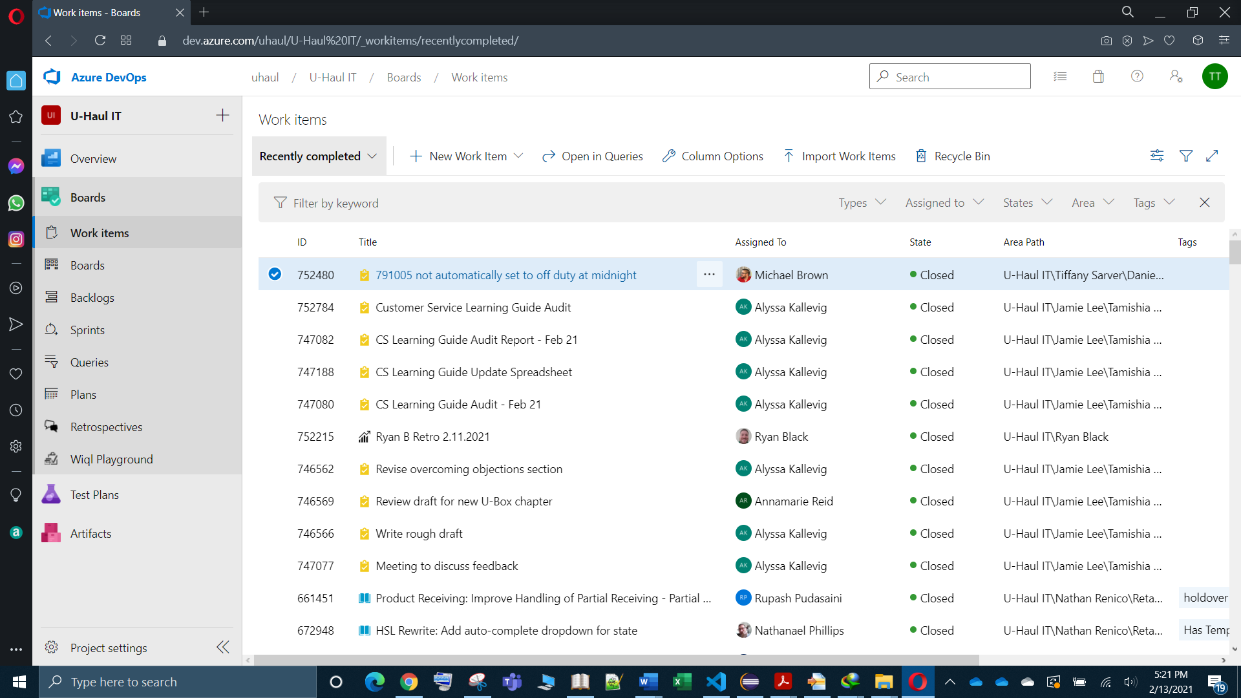

### Information of a work item

Let’s see what a work item that your team have completed looks like by choosing “Recently completed” from the page above (Azure DevOps > U-haul IT > Boards > Work Items), and then picking a random work item in the list, for example:

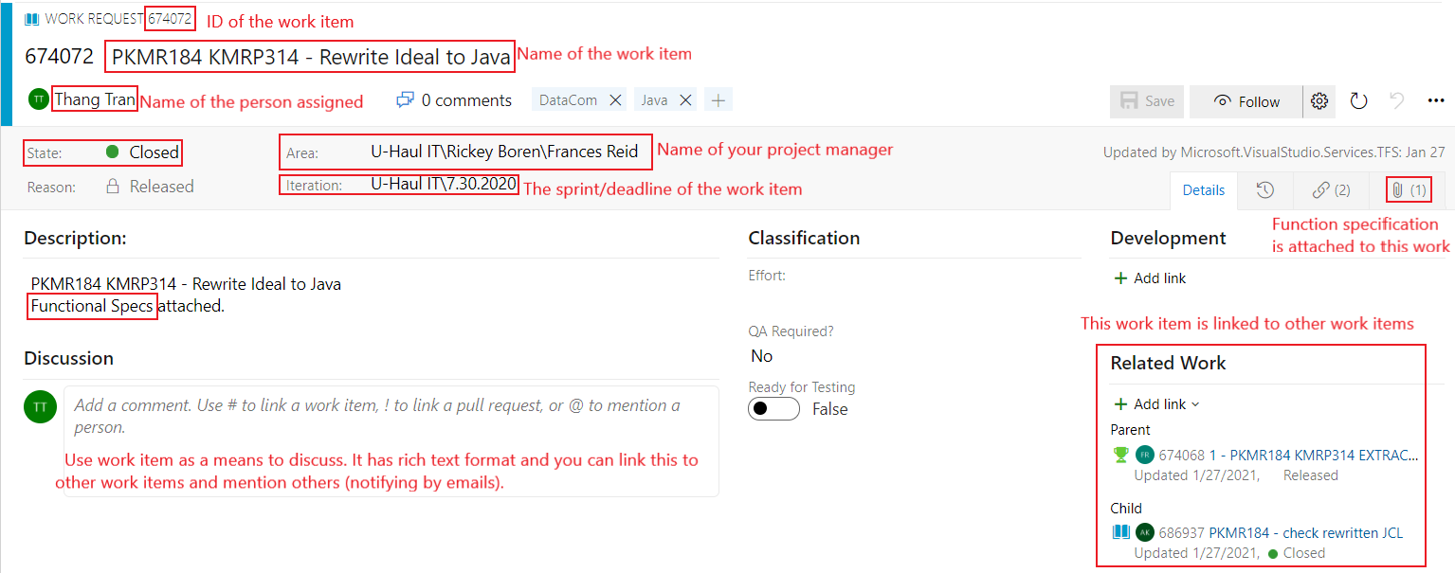

All work items in a project are split into **areas**, each area is managed by a project manager. One project has several managers.

Project managers create and assign their members work items, and members can also create and assign others work items. A work item is assigned often within a period of time/**sprint**, usually 2 weeks for Uhaul’s Software Development Department, and this period is called an **iteration**.

A big work item is split into smaller work items according to a hierarchy, which is usually (from big to small):

**Epic 🡪 Feature Request 🡪 Work Request 🡪 Task**

Java developers often works with only **Work Requests** and **Task**.

Epic

Feature Request

Work Request

Task

When you work on a work item, the work item’s **status** can be “**Not Started**”, “**Started**”, “**Active**”, “**Complete**”, “**Closed**”.

A work item can be linked to other works items as **related**/**parent**/**child**.

**Files** can be attached to a work item. One of the most important files is **Function Specification**, which describe the features that a program needs to have.

Team member can **discuss** on the work item page. Exchange message has rich text format, so you can insert pictures, link or mention someone. Notice the hint “*Use # to link a work item, ! to link a pull request, or @ to mention a person*”. If you mention someone by @, the mentioned person will be notified through email.

More on the options available atop any Work Item:

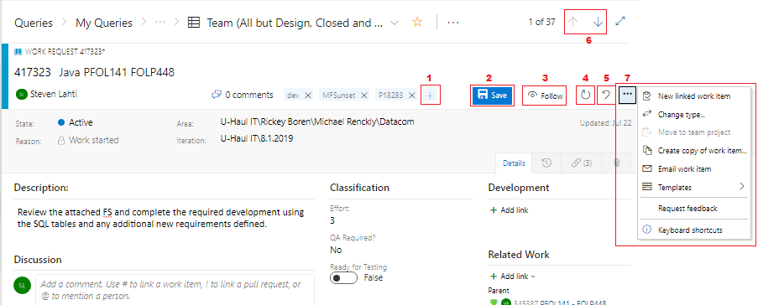

1. Add a Tag pertaining to the current Work Item
2. Save the Work Item
3. Receive e-mails of updates to the Work Item
4. Refresh the Work Item (useful if someone has changed it recently)
5. Revert any changes you have made back to what it was
6. Navigate to the next or previous item in the query
7. The ellipses drops down a menu of other options you have pertaining to the Work Item

### List work items: assigned to you, mentioning you, recently updated, etc

To list the work items assigned to you, mentioning you, recently updated, etc:

**Step 1 – choose Area:** From U-Haul It > Boards > Work Items, choose Area: your_manager, for example Michael Renchkly or Frances Reid for Java Developers

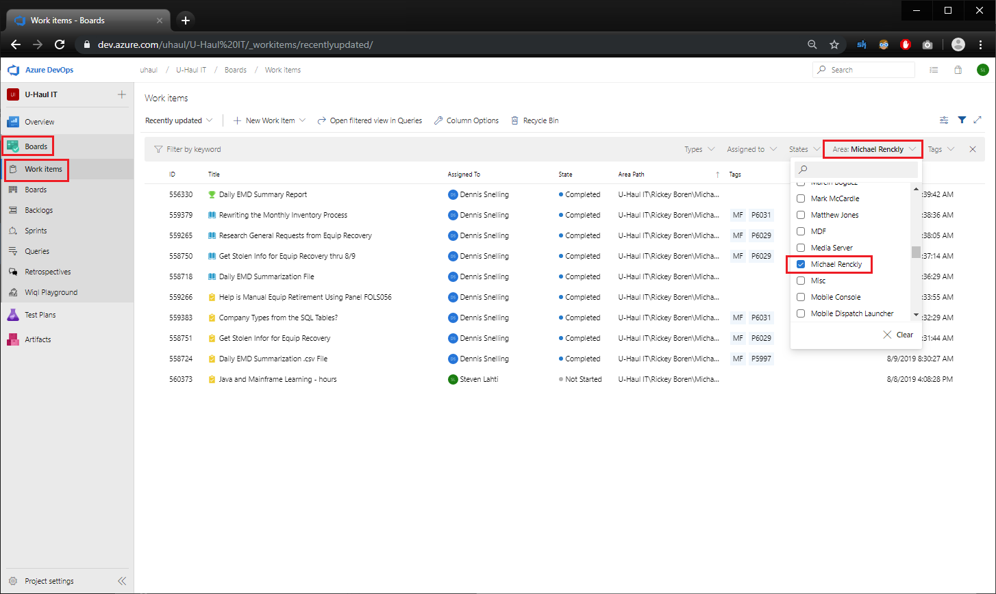

**Step 2**: From the drop down box, choose “Assigned to me” or “Mentioned”, “Recently updated”, etc:

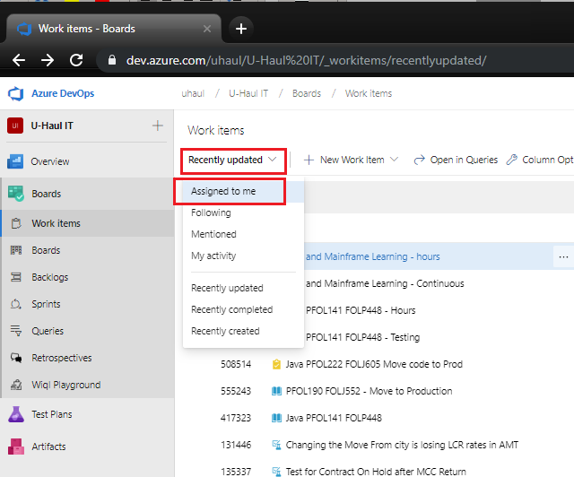

* **Assigned to me**: lists all work items assigned to you in the project in the order they were last updated. To open or update a work item, simply click its title.
* **Following**: lists work items that you're following.
* **Mentioned**: lists work items in which you've been mentioned in the last 30 days.
* **My activity**: lists work items that you've recently viewed or updated.
* **My team(s)**: lists work items that you're team members have recently viewed or updated.
* **Recently updated**: lists work items recently updated in the project.
* **Recently completed**: lists work items completed or closed in the project.
* **Recently created**: lists work items created within the last 30 days in the project.

### Change the states for your assigned work item

Note: “Closed” state doesn’t mean “Completed”; “Closed” means you abandon the work item. So, when you complete a work item, choose “Completed” first and then “Closed”.

### Assign a work item to someone

**Warning: once a work item is created, it cannot be deleted; it can be only closed.**

To create and assign a work item to someone (including yourself)

* Step 1: From Uhaul IT project, choose Boards > Work Items > New Work Item > Work request. Java developers often assign a “work request” (and rarely other type) to others. (There will be a note about assigning a “task” to others at the end).

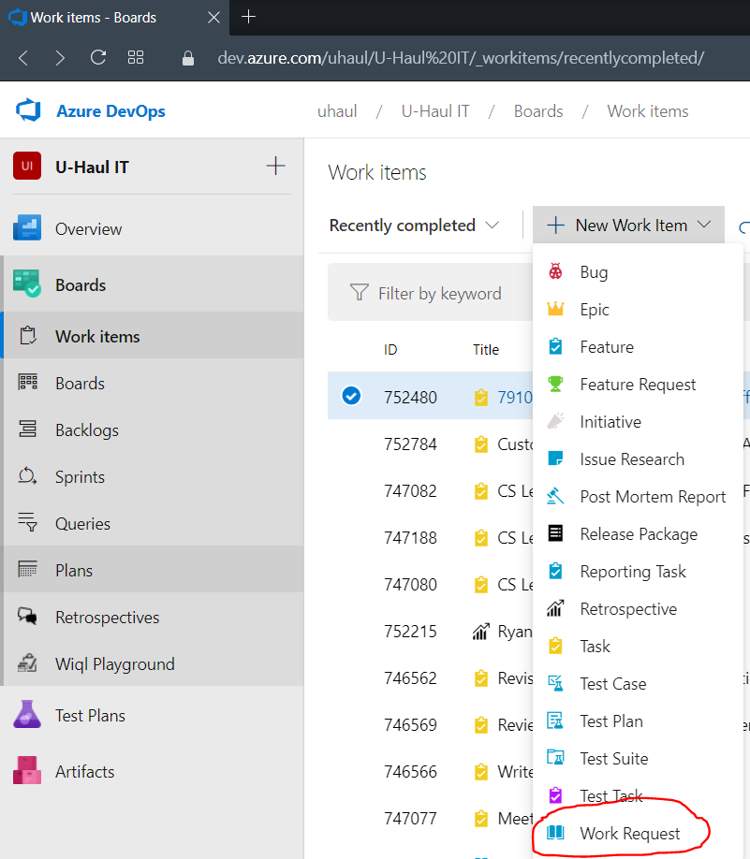

* Step 2: Fill in information for a work item (mentioned in the previous section) like: Title, Name of person that is assigned, Iteration (deadline), Area (project manager), Description. Drop “@Name” to email the person.

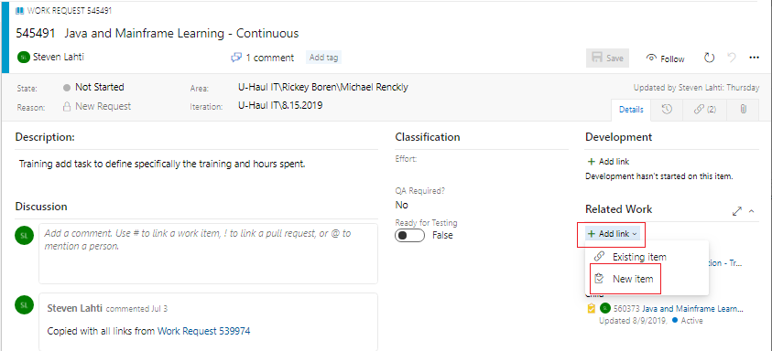

Note that you should link your work item to other related work items by “Add link” > “Existing Item”. You will be prompted to select a “Link type”, “Work Item Type” and enter a “Title” (and a “Comment”, optional)

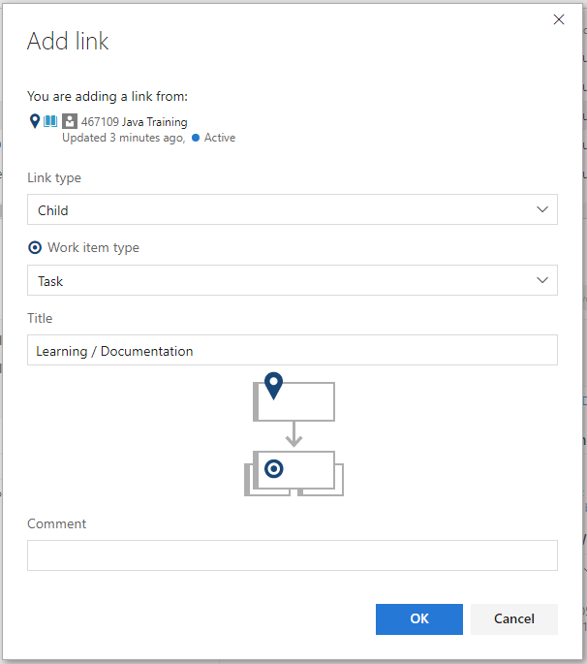

Note that if you create a “task”, you need to specify duration for the task by filling “Schedule – Estimated Hours Remaining”

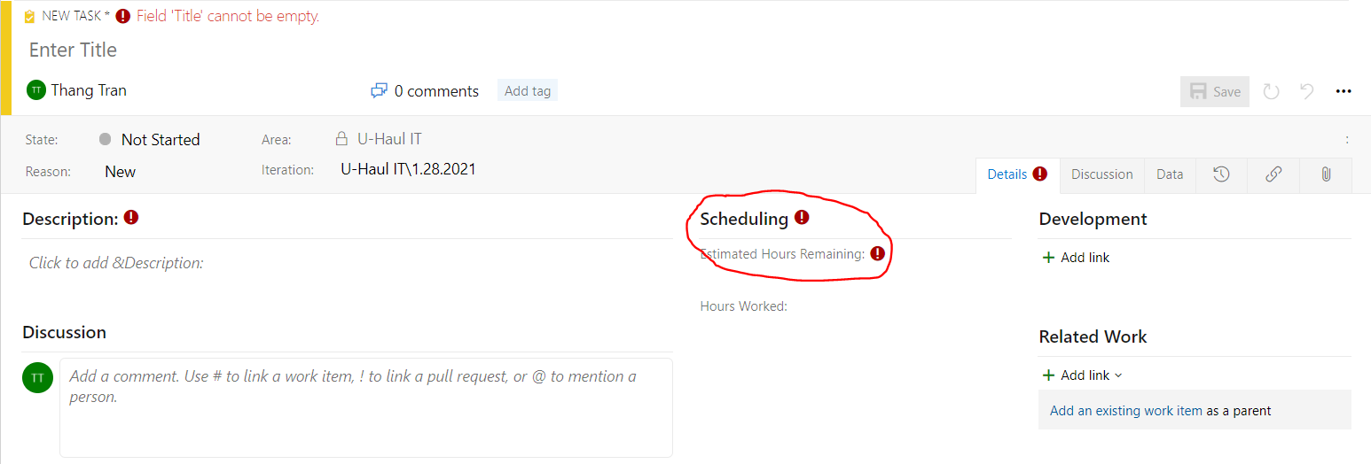

* Step 3: Save

### Query work items

Over time, you have a lot of work items; to search them according to some criteria, you create **queries**.

While on the Queries page, Click New > New Query

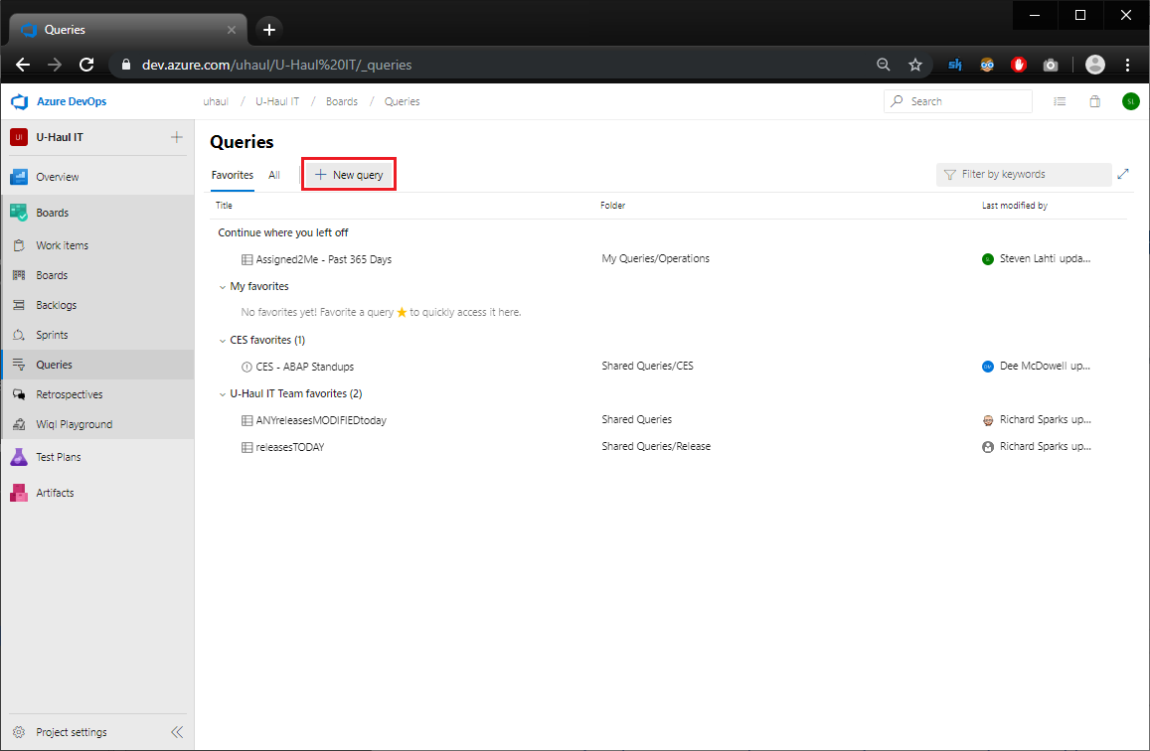

And then the Editor page helps you to set criteria for searching work items:

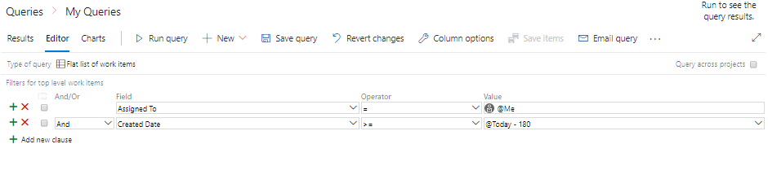

**A Single Condition search** is created by setting a specific field to be a specific value:

* Common “Field[s]” to search by:

Assigned To Area Path Created By Created Date Title Work Item Type

* Common Operators:

Contains Words <> (not equal to) = (equal to)

* If you select a certain Field, the Value’s dropdown will reflect that field’s available options

**Multiple Condition search** is created by combining several single condition search with “And/Or”.

* Click “Add new clause” to add more conditions.
* Place a check besides each condition then click on the “group selected clauses” button (resides on top row in the checkmark column)
* Note that if you need to perform an “Or” condition in a group, be sure that the first of the clauses is set to “And” and the rest of them set to “Or”

For example, if you need to query Work Items with the “State” to be either “Completed” or “Closed” amongst 3 people: Kothai, Savitha, Steven.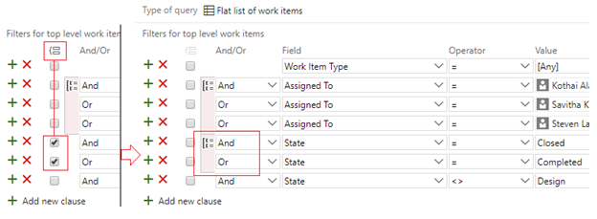

The final step is “**Run Query**” and you get the results at the bottom half:

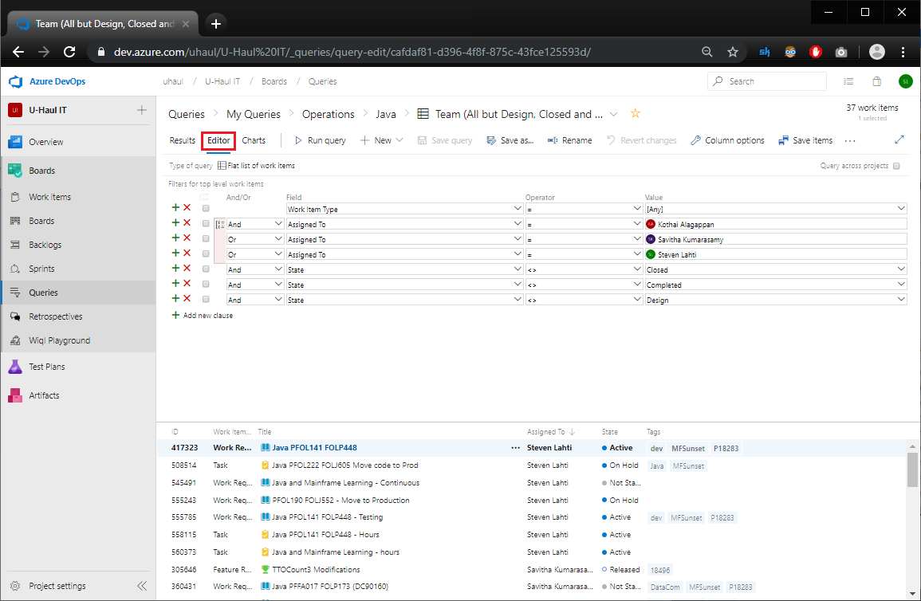

By clicking on CHARTS, you have the option to visualize the result by a chart: 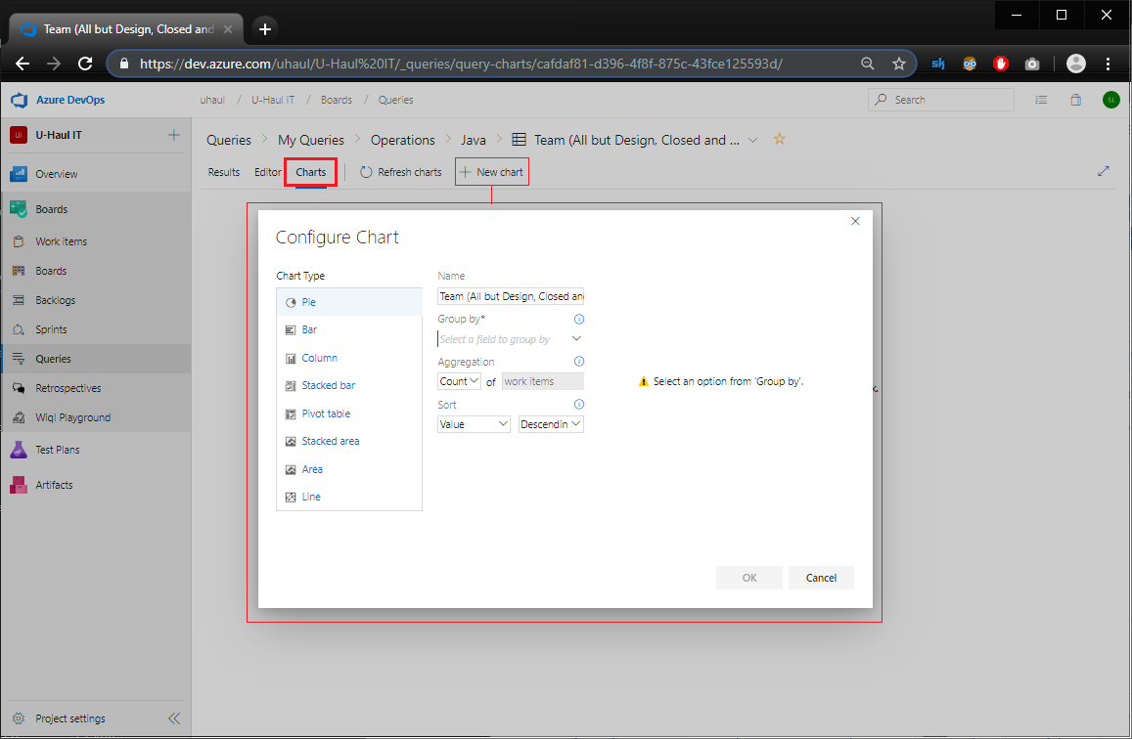

## Azure REPOS with Operations project

Azure REPOS is a version control system that supports both Git repos and Team Foundation Version Control (TFVC) repos. Uhaul uses TFVC repos.

Besides Azure Repos for TFVC repo, you can and should use **TFS plug-in in Eclipse**. **Azure Repos web portal** is more limited than the Eclipse plug-in, but ***Azure Repos web is still useful when the TFS Eclipse plug-in is not available***.

To use Azure REPOS:

* Log in to <https://dev.azure.com/uhaul/>, choose “uhaul” on the left panel and then “**Operations**” (not Uhaul IT)
* On the left panel, choose “Repos” > “Files” and you will see all the files in the repos.

Recall that Java developers work with only 6 folders:   
cesp01, cesp01_development, datacom, datacom_development, datasources, datasources_development

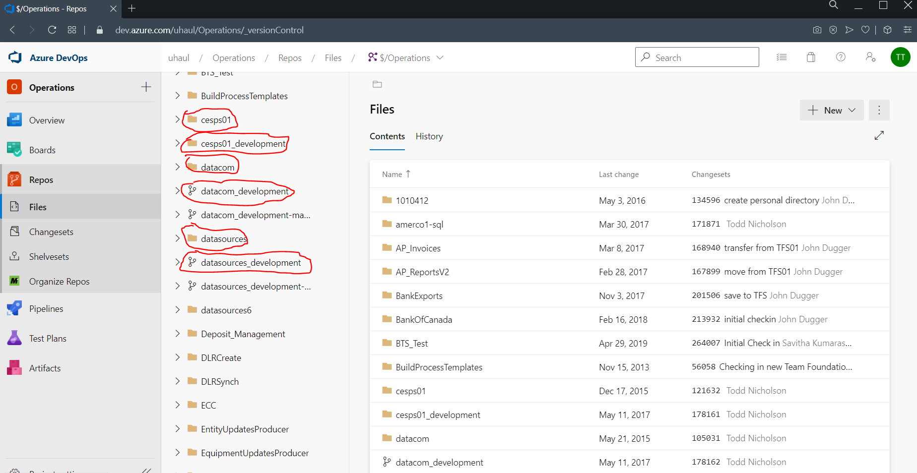

**Note that whatever you can do with Azure Repos web in the followings, you can do with TFS Eclipse plug-in.**

### See who commits what code

From the Repos page, just click on “History” and you will see who commit changes to what java program in the whole system. If you choose a specific file, the history will be restricted to that file.

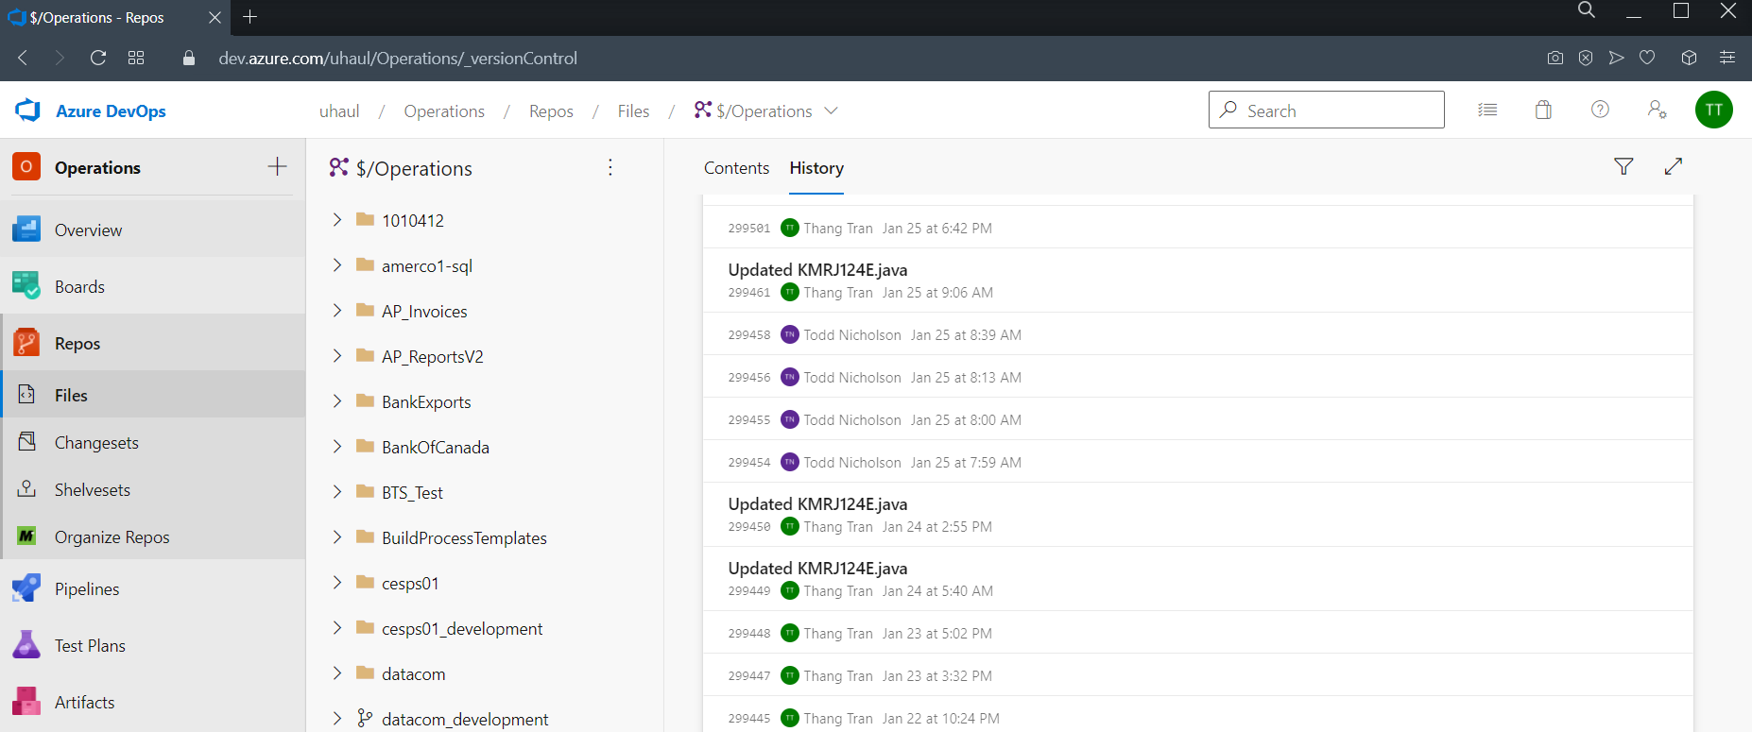

### Compare/Go back to an old version of your code

To compare/go back to an old version of your program code, browse to the file and then choose “History” (by default “Content” is chosen) and then click on the version you want to review:

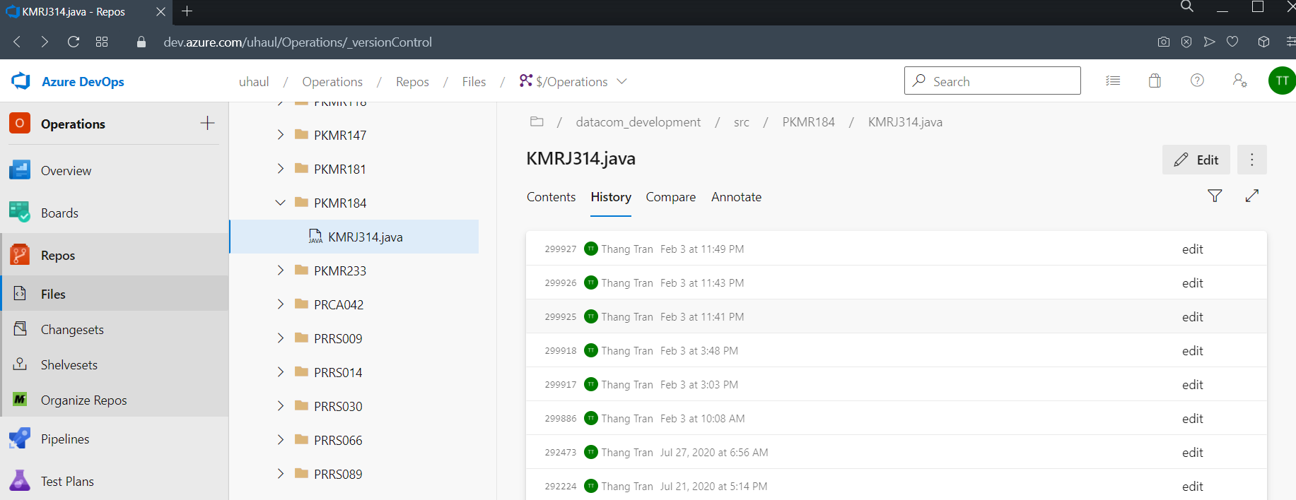

To see the code of the old version, choose “**Modified Content**” from the drop down box

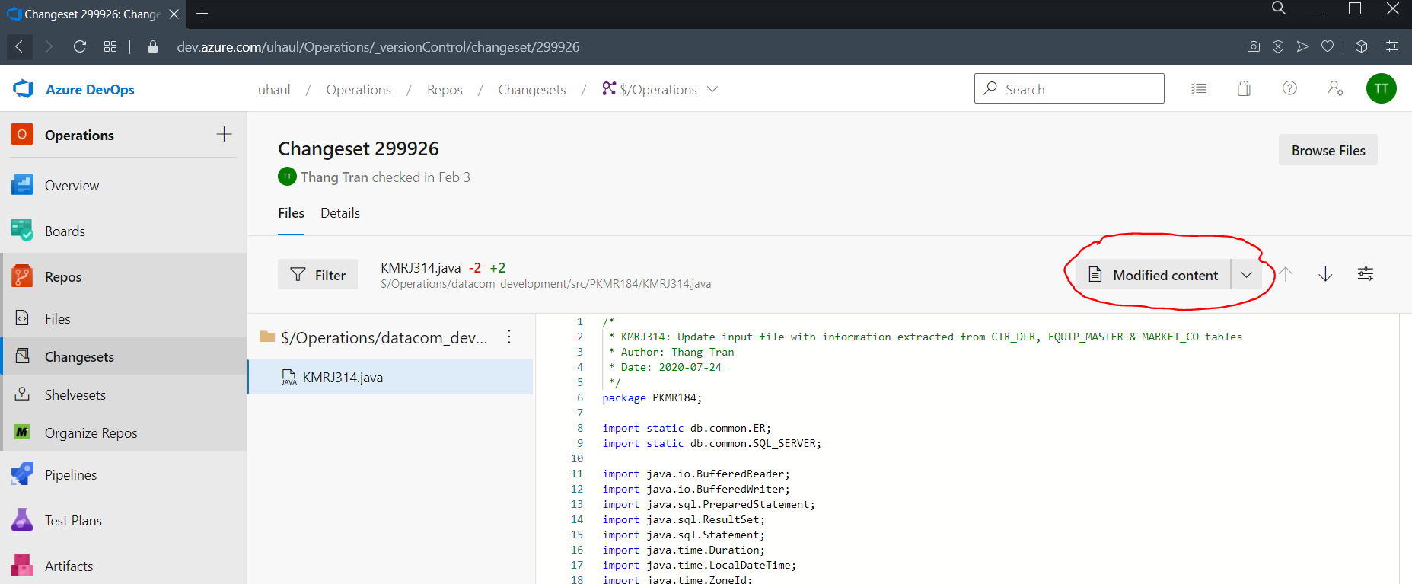

To compare the old version with the latest version, choose “Side by Side” or “Inline”

Side by side comparison:

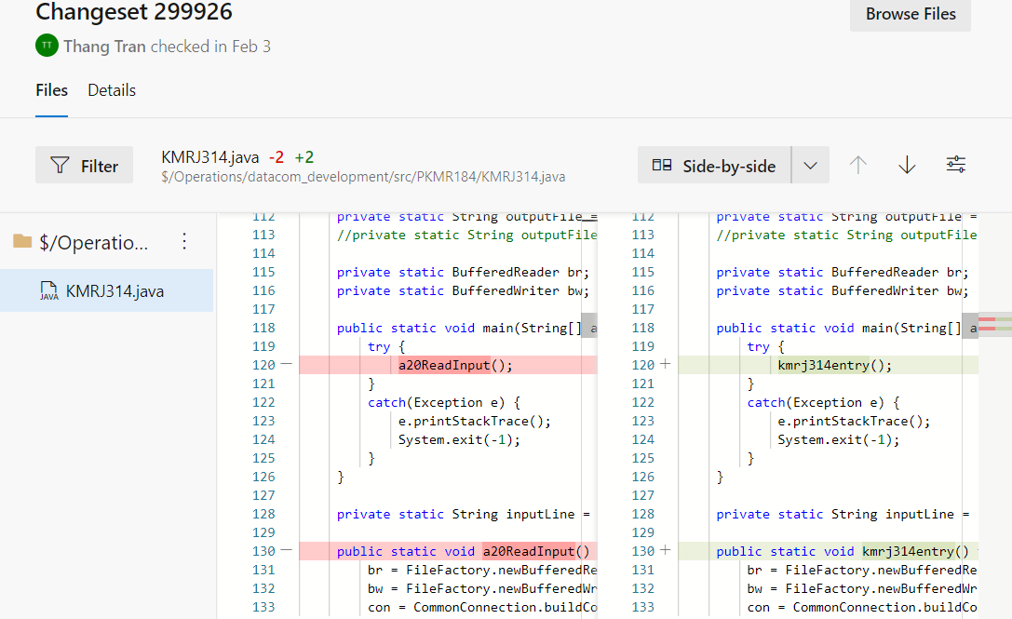

Inline comparison:

